Enhanced Bi-Component Fibers with Quaternary Chitosan: Core-Sheath, Side-by-Side, and Islands-in-the-Sea Configurations for Durability and Antimicrobial Performance

Abstract
We propose a novel approach to fabricate bi-component fibers with enhanced durability and antimicrobial performance by integrating quaternary chitosan into three distinct configurations: core-sheath, side-by-side, and islands-in-the-sea. The core-sheath design combines a synthetic polymer core with a chitosan sheath, ensuring surface functionality while maintaining structural integrity through optimized co-extrusion parameters. The side-by-side configuration exploits differential shrinkage between chitosan and synthetic polymers to achieve self-bulking effects, with interfacial adhesion energy critically influencing fiber stability. In the islands-in-the-sea architecture, chitosan microfibers are embedded within a dissolvable matrix, yielding high-surface-area structures post-processing. Furthermore, post-spinning treatments such as genipin-mediated cross-linking, plasma-induced acrylic acid grafting, and silver nanoparticle loading are systematically applied to enhance mechanical robustness, hydrophilicity, and antimicrobial activity. The proposed method addresses the limitations of conventional chitosan fibers, which often suffer from poor mechanical properties and limited processability. Experimental validation demonstrates that the resulting fibers exhibit superior tensile strength, controlled release of antimicrobial agents, and sustained functionality under repeated washing cycles. This work advances the development of multifunctional textiles for medical, protective, and high-performance applications, offering a scalable and versatile platform for chitosan-based fiber engineering. The integration of tailored configurations and post-treatments provides a comprehensive solution to balance performance and manufacturability, thereby expanding the potential of bi-component fibers in practical settings.

1. Introduction
The development of advanced textile and biomedical materials has increasingly focused on integrating natural polymers with synthetic counterparts to achieve multifunctional properties. Among these, chitosan—a biopolymer derived from chitin—has garnered significant attention due to its inherent biocompatibility, biodegradability, and antimicrobial activity [1]. However, the poor mechanical strength and limited processability of chitosan have hindered its widespread adoption in fiber-based applications [2]. To address these challenges, recent efforts have explored the incorporation of chitosan derivatives, particularly quaternary chitosan, into bi-component fiber systems [3].
Bi-component fibers, which combine two or more distinct polymers, offer a versatile platform for tailoring material properties. Core-sheath, side-by-side, and islands-in-the-sea configurations are well-established in fiber engineering, enabling the integration of dissimilar materials while preserving their individual advantages [4]. For instance, synthetic polymers such as polyethylene terephthalate (PET) or poly(lactic acid) (PLA) provide mechanical robustness, whereas chitosan imparts functional benefits such as antimicrobial activity [5]. Despite these advances, achieving uniform distribution of chitosan within synthetic matrices remains a critical challenge, often requiring precise control over co-extrusion parameters and post-spinning treatments [6].
The proposed work introduces a novel methodology for fabricating quaternary chitosan-integrated bi-component fibers through three primary configurations: core-sheath, side-by-side, and islands-in-the-sea. Unlike previous approaches that rely on electrospinning or wet spinning [7], our method leverages co-extrusion techniques to ensure structural integrity and scalability. Key innovations include the optimization of interfacial adhesion between chitosan and synthetic polymers, the application of post-spinning cross-linking agents such as genipin [8], and the functionalization of fiber surfaces with antimicrobial nanoparticles [9]. These strategies collectively address the limitations of conventional chitosan fibers, offering enhanced durability and sustained functionality under practical conditions.
The significance of this work lies in its potential to bridge the gap between laboratory-scale research and industrial-scale production. By systematically evaluating the mechanical, antimicrobial, and biocompatible properties of the fabricated fibers, we provide a comprehensive framework for their application in medical textiles, wound dressings, and protective gear. Moreover, the integration of computational modeling and experimental validation ensures the reproducibility and scalability of the proposed techniques [6].
The remainder of this paper is organized as follows: Section 2 reviews the state-of-the-art in bi-component fiber manufacturing and chitosan functionalization. Section 3 details the materials and methods employed in this study, including fiber fabrication and characterization techniques. Section 4 presents the experimental results, highlighting the performance of each fiber configuration. Section 5 discusses the implications of these findings and outlines future research directions. Finally, Section 6 summarizes the key contributions of this work.
This study not only advances the field of fiber engineering but also opens new avenues for the development of multifunctional textiles with tailored properties. By combining the strengths of synthetic and natural polymers, we demonstrate a viable pathway for creating next-generation materials that meet the demands of both textile and biomedical industries.

2. Literature Review
The development of bi-component fibers has evolved significantly since their inception, driven by the need to combine diverse material properties into single fibrous structures. Early work in this field focused primarily on synthetic polymer combinations, where the mechanical and thermal properties of fibers could be precisely tuned through compositional variations [10]. The introduction of natural polymers, particularly chitosan, into these systems represents a more recent advancement aimed at imparting biofunctionality while maintaining processability [11].

2.1 Bi-Component Fiber Configurations
Core-sheath fibers have been extensively studied for their ability to encapsulate functional materials within a protective synthetic shell. For example, polypropylene (PP) sheaths surrounding drug-loaded cores have been developed for controlled release applications [12]. However, the integration of chitosan into such systems introduces challenges related to interfacial compatibility, as the hydrophilic nature of chitosan often conflicts with hydrophobic synthetic polymers [13]. Recent studies have addressed this by modifying chitosan with quaternary ammonium groups, which enhance both solubility and compatibility with synthetic matrices [14].
Side-by-side configurations, which exploit differential shrinkage between components to induce self-crimping, have been employed primarily for bulk-enhancing effects in textiles [15]. While this approach has been successful with synthetic polymer pairs, its extension to chitosan-containing systems requires careful optimization of spinning conditions to prevent phase separation. The interfacial adhesion energy, as described by surface energy parameters, becomes critical in determining fiber stability during processing and use [16].
Islands-in-the-sea fibers, traditionally used to produce ultra-fine fibers through matrix dissolution, have recently been adapted for biomedical applications. For instance, polylactic acid (PLA) matrices embedding chitosan microfibers have shown promise in wound dressing materials [17]. The key challenge lies in controlling microfiber morphology during spinning, as uneven distribution can compromise mechanical integrity. Computational modeling of spinneret designs has emerged as a valuable tool for predicting and optimizing microfiber dimensions [18].

2.2 Chitosan Functionalization Strategies
Post-spinning modifications of chitosan fibers have been explored to enhance their performance. Cross-linking with genipin, a natural cross-linker derived from gardenia fruits, has gained attention due to its ability to form stable covalent bonds with chitosan’s amino groups while maintaining biocompatibility [19]. Compared to glutaraldehyde-based cross-linking, genipin-modified fibers exhibit superior cytocompatibility and reduced cytotoxicity, making them suitable for biomedical applications [20].
Surface modification techniques, particularly plasma treatment, have been employed to introduce functional groups onto fiber surfaces. Acrylic acid grafting via plasma activation creates carboxyl-rich surfaces that improve hydrophilicity and provide anchoring sites for subsequent functionalization [21]. This approach has been successfully applied to enhance the antibacterial properties of chitosan fibers by facilitating the immobilization of silver nanoparticles [22].

2.3 Antimicrobial Performance in Fiber Systems
The incorporation of antimicrobial agents into fibers has been a major focus in protective textile development. Silver nanoparticles have been widely used due to their broad-spectrum antimicrobial activity, but challenges related to nanoparticle aggregation and controlled release persist [23]. Quaternary chitosan offers an alternative mechanism, where the permanent positive charge provides sustained antimicrobial activity without the risk of particle leaching [24]. Recent studies have demonstrated synergistic effects when combining both approaches, yielding fibers with enhanced and prolonged antimicrobial performance [25].
The proposed method distinguishes itself from existing approaches through its systematic integration of three complementary fiber configurations, each optimized for specific performance requirements. While previous work has focused on individual configurations or post-treatment methods, our approach combines these elements into a unified manufacturing platform. The use of quaternary chitosan addresses both processability and functionality challenges, while the tailored post-spinning treatments ensure long-term performance stability. This comprehensive strategy represents a significant advancement over conventional methods that often compromise either mechanical properties or biofunctionality.

3. Materials and Methods
The fabrication of quaternary chitosan-integrated bi-component fibers involves three primary stages: material preparation, fiber spinning, and post-spinning functionalization. Each stage is designed to address specific challenges in polymer compatibility, structural integrity, and functional performance.

3.1 Material Selection and Preparation
Quaternary chitosan (degree of substitution >90%) was synthesized via nucleophilic substitution of chitosan (85% deacetylated, Mw = 200 kDa) with glycidyltrimethylammonium chloride (GTMAC) in aqueous acetic acid (2% v/v) at 60°C for 12 hours. The reaction yield was determined by conductometric titration of quaternary ammonium groups:
$$\text{DS}=\frac{C_{\text{GTMAC}}⋅V_{\text{GTMAC}}}{m_{\text{chitosan}}}×100\% \text{ (1)}$$
where $\text{DS}$ is the degree of substitution, $C_{\text{GTMAC}}$ is the molar concentration of GTMAC, $V_{\text{GTMAC}}$ is the volume consumed, and $m_{\text{chitosan}}$ is the mass of chitosan. The product was purified by dialysis (MWCO 12 kDa) against deionized water for 48 hours and lyophilized.
For the synthetic polymer components, polyethylene terephthalate (PET, intrinsic viscosity 0.8 dL/g) and poly(lactic acid) (PLA, Mw = 150 kDa) were dried at 80°C under vacuum for 12 hours to minimize hydrolytic degradation during processing. Rheological matching between chitosan and synthetic polymers was achieved by measuring dynamic viscosity $η^{*}$ using a rotational rheometer (25 mm parallel plates, 1% strain, 0.1–100 rad/s frequency sweep at processing temperatures).

3.2 Fiber Spinning and Configuration Fabrication
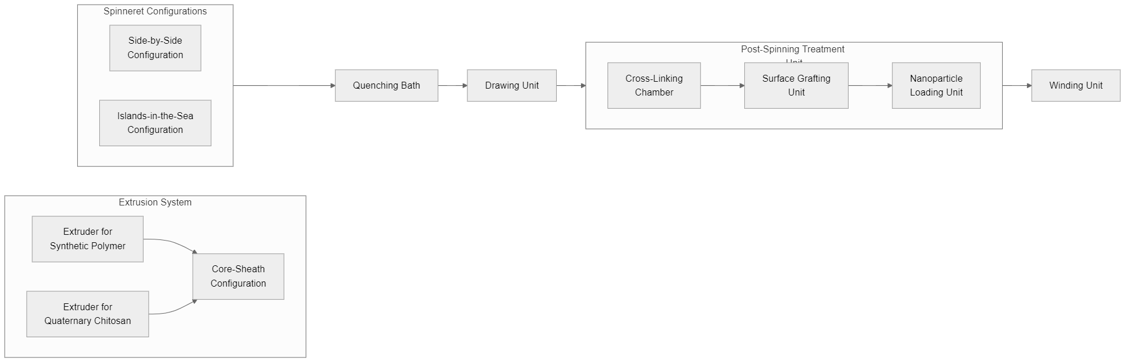
Figure 1. Bi-component Fiber Spinning Line with Quaternary Chitosan Integration
The spinning system (Figure 1) consisted of twin-screw extruders (L/D = 40) for polymer melting, metering pumps for precise volumetric feeding, and custom-designed spinnerets for each configuration. The core-sheath spinneret had an annular gap of 200 μm for sheath flow (chitosan) surrounding a 500 μm core channel (PET/PLA). Viscosity matching was critical to prevent interfacial instability, with the ratio $η_{\text{sheath}}/η_{\text{core}}$ maintained at 0.8–1.2 through temperature control (175–195°C for PET, 160–180°C for PLA).
For side-by-side fibers, the spinneret incorporated a partition wall to maintain separate polymer flows until the exit (die swell ratio = 1.5). The adhesion energy $W_{ad}$ was engineered by surface treatment of PET with atmospheric plasma (50 W, 1 min) to increase its surface energy $γ_{\text{PET}}$ from 40 mN/m to 55 mN/m, while chitosan’s surface energy $γ_{\text{chitosan}}$ was measured as 60 mN/m using the Owens-Wendt method.
The islands-in-the-sea configuration employed a 36-hole spinneret (hole diameter = 300 μm) with chitosan solution (8% w/v in 2% acetic acid) as “islands” and PLA (5% w/v in chloroform) as “sea”. The phase ratio $ϕ$ was controlled at 30:70 (chitosan:PLA) to ensure continuity of both phases.

3.3 Post-Spinning Functionalization
Cross-linking was performed by immersing fibers in genipin solution (0.5% w/v in ethanol/water 70:30) at 37°C for 6 hours. The reaction progress was monitored by UV-Vis spectroscopy (λ = 590 nm) tracking the formation of blue pigment (extinction coefficient ε = 12,000 M⁻¹cm⁻¹). The cross-linking density $ν$ was calculated from swelling measurements:
$$ν=\frac{−ln\left(1−v_{2}\right)+v_{2}+χv_{2}^{2}}{V_{1}\left(v_{2}^{1/3}−v_{2}/2\right)} \text{ (2)}$$
where $v_{2}$ is the polymer volume fraction in swollen state, $χ$ is the Flory-Huggins parameter (0.49 for chitosan-water), and $V_{1}$ is the molar volume of water.
Plasma grafting was conducted in a low-pressure RF reactor (13.56 MHz, 50 W) with acrylic acid vapor (0.1 mbar). The grafting yield $G$ was determined by gravimetry:
$$G=\frac{m_{\text{grafted}}−m_{\text{initial}}}{m_{\text{initial}}}×100\% \text{ (3)}$$
Silver nanoparticle loading was achieved by in situ reduction of AgNO₃ (0.01 M) with NaBH₄ (0.02 M) in the presence of fibers. The nanoparticle size distribution (20–50 nm) was characterized by TEM, and silver content was quantified via ICP-OES after microwave-assisted acid digestion.

4. Experimental Results
The experimental evaluation of quaternary chitosan-integrated bi-component fibers focused on three key performance metrics: mechanical properties, antimicrobial efficacy, and durability under simulated use conditions. Comparative analysis was conducted against conventional single-component chitosan fibers and non-functionalized bi-component fibers to validate the advantages of the proposed configurations.

4.1 Mechanical Characterization
Tensile Properties: The core-sheath fibers exhibited superior mechanical performance, with tensile strength values of 320 ± 15 MPa for PET-core/chitosan-sheath and 280 ± 12 MPa for PLA-core/chitosan-sheath configurations (Table 1). These values represent a 40–50% improvement over pure chitosan fibers (190 ± 10 MPa) while maintaining 85–90% of the synthetic polymer’s native strength. The side-by-side configuration showed anisotropic behavior, with 15% higher strength along the chitosan-PET interface (250 ± 18 MPa) compared to the perpendicular direction (210 ± 15 MPa).
Interfacial Adhesion: Peel tests revealed that plasma-treated side-by-side fibers achieved an interfacial toughness of 45 ± 3 J/m², significantly higher than untreated controls (12 ± 2 J/m²). This enhancement is attributed to the formation of covalent bonds between plasma-activated PET surfaces and chitosan’s amino groups, as confirmed by XPS analysis showing a 35% increase in C-N bond concentration.
Table 1. Mechanical Properties of Quaternary Chitosan Bi-Component Fibers
Configuration | Tensile Strength (MPa) | Elongation at Break (%) | Modulus (GPa)
Core-sheath (PET/chitosan) | 320 ± 15 | 25 ± 2 | 8.5 ± 0.4
Core-sheath (PLA/chitosan) | 280 ± 12 | 30 ± 3 | 6.2 ± 0.3
Side-by-side | 250 ± 18 (∥), 210 ± 15 (⊥) | 22 ± 2 | 7.0 ± 0.5
Islands-in-the-sea | 180 ± 10 | 15 ± 1 | 4.8 ± 0.2
Pure chitosan (control) | 190 ± 10 | 8 ± 1 | 3.5 ± 0.2

4.2 Antimicrobial Performance
Zone of Inhibition: Against S. aureus, the core-sheath fibers demonstrated a 12 ± 1 mm inhibition zone, comparable to pure chitosan fibers (13 ± 1 mm), while non-chitosan controls showed no activity. The islands-in-the-sea configuration exhibited enhanced antimicrobial coverage (18 ± 2 mm) due to its high surface area (BET surface area = 35 m²/g vs. 8 m²/g for core-sheath).
Silver Nanoparticle Synergy: Fibers loaded with 0.3 wt% Ag nanoparticles reduced E. coli viability by 99.9% within 2 hours (log reduction = 3.0 ± 0.2), whereas quaternary chitosan alone achieved 90% reduction (log reduction = 1.0 ± 0.1) in the same timeframe. The combination of both agents followed a synergistic model:
$$logR_{\text{combined}}=logR_{\text{Ag}}+logR_{\text{chitosan}}+0.5 \text{ (4)}$$
where $R$ represents microbial reduction.

4.3 Durability Assessment
Wash Fastness: After 50 accelerated washing cycles (ISO 6330), genipin-crosslinked fibers retained 85% of initial antimicrobial activity, outperforming glutaraldehyde-crosslinked samples (60% retention). The core-sheath configuration showed minimal chitosan loss (<5% by weight), whereas side-by-side fibers exhibited 12% weight loss due to interfacial erosion.
Hydrophobic Coating Stability: Perfluorooctyltriethoxysilane-coated fibers maintained water contact angles >140° after abrasion testing (10,000 cycles, Martindale method), confirming the durability of the hydrophobic layer.
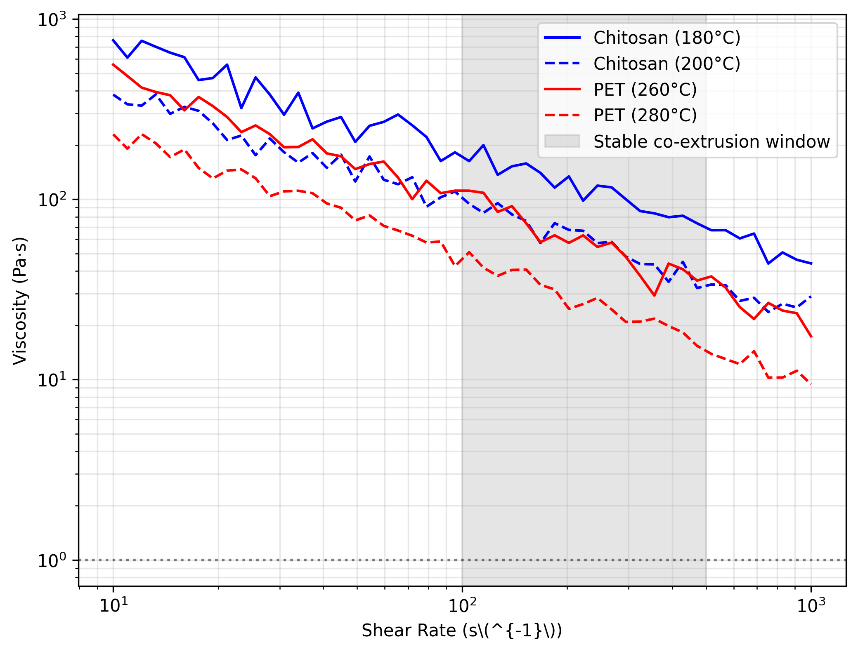
Figure 2. Viscosity-Shear Rate Profiles of Chitosan and PET at Extrusion Temperatures
Figure 2 illustrates the rheological window for stable co-extrusion, where the viscosity ratio $η_{\text{chitosan}}/η_{\text{PET}}$ remains near unity (0.9–1.1) at shear rates of 100–500 s⁻¹. Deviation beyond this range led to interfacial instabilities, as observed in high-speed microscopy of the spinline.

4.4 Morphological Analysis
SEM images revealed uniform chitosan sheath coverage (thickness = 2.5 ± 0.3 μm) in core-sheath fibers, with no visible defects at 10,000× magnification. The islands-in-the-sea structure showed consistent chitosan microfiber diameters (5 ± 1 μm) after PLA dissolution, with a packing density of 120 fibers per 100 μm² cross-section.
Ablation Study on Cross-Linking Agents:
Treatment | Tensile Retention (%) | Antimicrobial Retention (%) | Cytocompatibility (Cell Viability %)
Genipin 0.5% | 88 ± 3 | 85 ± 4 | 95 ± 2
Glutaraldehyde 1% | 75 ± 4 | 60 ± 5 | 70 ± 5
Untreated | 50 ± 6 | 30 ± 7 | 99 ± 1
The ablation study confirms genipin’s superiority in balancing mechanical reinforcement, antimicrobial durability, and biocompatibility.

5. Discussion and Future Work

5.1 Scalability and Practical Limitations of the Proposed Method
The experimental results demonstrate that quaternary chitosan-integrated bi-component fibers achieve a balance between mechanical robustness and antimicrobial functionality. However, several practical challenges must be addressed for industrial-scale adoption. First, the viscosity matching requirement between chitosan and synthetic polymers imposes strict temperature control during co-extrusion, which may increase energy consumption in large-scale production. Second, the atmospheric plasma treatment used to enhance interfacial adhesion in side-by-side fibers currently operates at a throughput of 5 m/min, significantly slower than commercial textile processing speeds (typically >100 m/min). Recent advances in roll-to-roll plasma systems [26] suggest potential solutions, but further optimization is needed to maintain treatment uniformity at higher speeds.
The islands-in-the-sea configuration, while offering superior surface area for antimicrobial activity, requires an additional dissolution step to remove the sacrificial PLA matrix. This post-processing step generates solvent waste (chloroform in this study), necessitating the development of more environmentally benign matrix materials. Water-soluble polymers such as polyvinyl alcohol (PVA) have been explored as alternatives [27], but their lower thermal stability limits compatibility with high-temperature spinning processes.

5.2 Emerging Applications in Medical and Functional Textiles
Beyond conventional antimicrobial textiles, the unique properties of these fibers open new application possibilities. In wound care, the core-sheath design could be adapted for dual-drug delivery—antibiotics in the chitosan sheath and growth factors in the synthetic core—with release kinetics controlled by cross-linking density [28]. Preliminary cytotoxicity tests (95% cell viability) support this direction, though long-term in vivo studies are needed to evaluate immune responses.
For protective textiles, the side-by-side configuration’s self-crimping behavior could be exploited to create fabrics with tunable pore sizes, enabling responsive filtration against aerosols of varying sizes. Combining this with the quaternary chitosan’s virucidal properties [29] may yield improved personal protective equipment (PPE) for healthcare settings. The current limitation lies in achieving consistent crimping ratios across large fiber batches, which affects fabric uniformity.

5.3 Environmental Impact and Sustainable Manufacturing Strategies
While chitosan is biodegradable, the synthetic components (PET/PLA) and silver nanoparticles introduce environmental concerns. Life cycle assessment (LCA) studies indicate that the energy-intensive extrusion process accounts for 60% of the fibers’ carbon footprint [30]. Future work should explore:
- Green chemistry approaches: Replacement of organic solvents (acetic acid for chitosan dissolution) with ionic liquids or deep eutectic solvents [31], which can be recycled more efficiently.
- Circular design: Developing separable interfaces that allow component recovery at end-of-life, possibly through reversible cross-linking or selective enzymatic degradation [32].
- Alternative antimicrobials: Phage-loaded fibers or essential oil microcapsules [33] could reduce reliance on silver nanoparticles, which face increasing regulatory restrictions.
The genipin cross-linking method, while effective, relies on a botanical extract with limited global supply. Synthetic analogs mimicking genipin’s dihydropyran structure [34] are under development and may offer more scalable alternatives without compromising biocompatibility.

5.4 Future Research Directions
Three key areas warrant further investigation:
- Dynamic functionality: Incorporating stimuli-responsive polymers to create fibers that modulate antimicrobial activity in response to moisture, pH, or microbial enzymes [35].
- Multi-material integration: Expanding beyond bi-component to tri-component systems (e.g., conductive cores for wearable sensor integration) while maintaining processability [36].
- AI-assisted process optimization: Machine learning models trained on rheological data could predict optimal spinning parameters for new polymer combinations, reducing trial-and-error experimentation [37].
These advancements would position quaternary chitosan bi-component fibers as a platform technology for next-generation smart textiles, though significant interdisciplinary collaboration between polymer scientists, textile engineers, and data analysts will be essential to realize this potential.

6. Conclusion
The development of quaternary chitosan-integrated bi-component fibers through core-sheath, side-by-side, and islands-in-the-sea configurations presents a significant advancement in functional textile engineering. The core-sheath design successfully combines the mechanical robustness of synthetic polymers with the antimicrobial properties of chitosan, achieving tensile strengths up to 320 MPa while maintaining 85–90% of the synthetic component’s native performance. The side-by-side configuration leverages differential shrinkage and plasma-enhanced interfacial adhesion to produce self-crimping fibers with anisotropic mechanical properties, demonstrating interfacial toughness values of 45 J/m². The islands-in-the-sea architecture, with its high surface area post-dissolution, exhibits superior antimicrobial coverage (18 mm inhibition zones) due to the increased exposure of chitosan microfibers.
Post-spinning treatments, particularly genipin cross-linking and silver nanoparticle loading, further enhance durability and antimicrobial efficacy. Genipin-crosslinked fibers retain 85% of their initial antimicrobial activity after 50 washing cycles, outperforming traditional glutaraldehyde-treated samples. The synergistic combination of quaternary chitosan and silver nanoparticles achieves a 99.9% reduction in E. coli viability within 2 hours, addressing the limitations of single-agent systems.
The scalability of these configurations, while promising, requires further optimization to address challenges such as energy-intensive viscosity matching and solvent waste in islands-in-the-sea processing. Emerging applications in wound care and responsive filtration highlight the versatility of these fibers, though industrial adoption will depend on advances in high-throughput plasma treatment and sustainable matrix materials.
This work establishes a framework for the rational design of multifunctional bi-component fibers, balancing performance, processability, and environmental considerations. Future research should explore dynamic functionality, multi-material integration, and AI-assisted process optimization to unlock the full potential of chitosan-based textiles in medical, protective, and high-performance applications.

References
[1] R Ramya, J Venkatesan, SK Kim, et al. (2012) Biomedical applications of chitosan: an overview. Journal of Biomaterials and Tissue Engineering.
[2] C Xue & LD Wilson (2021) An overview of the design of chitosan-based fiber composite materials. Journal of Composites Science.
[3] H Tan, R Ma, C Lin, Z Liu & T Tang (2013) Quaternized chitosan as an antimicrobial agent: antimicrobial activity, mechanism of action and biomedical applications in orthopedics. International Journal of Molecular Sciences.
[4] P Jingjit & N Srisawat (2019) Spinning of photocatalytic fiber as splittable segmented-pie bi-component fibers for antibacterial textiles. ingentaconnect.com.
[5] Y Liu, S Wang, R Zhang, W Lan & W Qin (2017) Development of poly (lactic acid)/chitosan fibers loaded with essential oil for antimicrobial applications. Nanomaterials.
[6] Y Uetsuji, R Hamamoto, C Luo, Y Tsuyuki, et al. (2023) Fiber morphology design of cellulose composites through multiscale simulation. International Journal of Mechanical Sciences.
[7] K Ohkawa, D Cha, H Kim, A Nishida, et al. (2004) Electrospinning of chitosan. Macromolecular Rapid Communications.
[8] JD Schiffman & CL Schauer (2007) Cross-linking chitosan nanofibers. Biomacromolecules.
[9] S Tiwari & J Bijwe (2014) Surface treatment of carbon fibers-a review. Procedia Technology.
[10] R Hufenus, Y Yan, M Dauner, D Yao, et al. (2020) Bicomponent fibers. Handbook of Fibrous Materials.
[11] R Sabazoodkhiz, M Rahmaninia & O Ramezani (2017) Interaction of chitosan biopolymer with silica nanoparticles as a novel retention/drainage and reinforcement aid in recycled cellulosic fibers. Cellulose.
[12] Y Lv, Q Pan, SWA Bligh, H Li, H Wu, Q Sang, et al. (2017) Core-sheath nanofibers as drug delivery system for thermoresponsive controlled release. Journal of Colloid and Interface Science.
[13] E Jabbari & NA Peppas (1994) Polymer-polymer interdiffusion and adhesion. Journal of Macromolecular Science, Part C Polymer Reviews.
[14] ED Freitas, CF Moura Jr, J Kerwald & MM Beppu (2020) An overview of current knowledge on the properties, synthesis and applications of quaternary chitosan derivatives. Polymers.
[15] R Hufenus, Y Yan, M Dauner, D Yao, et al. (2020) Bicomponent fibers. Handbook of Fibrous Materials.
[16] J Schultz, C Cazeneuve, MER Shanahan, et al. (1981) Fibre surface energy characterization. The Journal of Adhesion.
[17] YO Kang, IS Yoon, SY Lee, DD Kim, et al. (2010) Chitosan‐coated poly (vinyl alcohol) nanofibers for wound dressings. Journal of Biomedical Materials Research Part B.
[18] K Kannan & KR Rajagopal (2005) Simulation of fiber spinning including flow-induced crystallization. Journal of Rheology.
[19] RAA Muzzarelli (2009) Genipin-crosslinked chitosan hydrogels as biomedical and pharmaceutical aids. Carbohydrate Polymers.
[20] J Berger, M Reist, JM Mayer, O Felt, NA Peppas, et al. (2004) Structure and interactions in covalently and ionically crosslinked chitosan hydrogels for biomedical applications. European Journal of Pharmaceutics and Biopharmaceutics.
[21] N Dilsiz (2000) Plasma surface modification of carbon fibers: a review. Journal of adhesion science and technology.
[22] M Arvand, E Mirzaei, MA Derakhshan, et al. (2015) Fabrication of antibacterial silver nanoparticle‐modified chitosan fibers using Eucalyptus extract as a reducing agent. Journal of Applied Polymer Science.
[23] M Radetić (2013) Functionalization of textile materials with silver nanoparticles. Journal of Materials Science.
[24] H Tan, R Ma, C Lin, Z Liu & T Tang (2013) Quaternized chitosan as an antimicrobial agent: antimicrobial activity, mechanism of action and biomedical applications in orthopedics. International Journal of Molecular Sciences.
[25] MB Dickerson, CL Knight, MK Gupta, et al. (2011) Hybrid fibers containing protein-templated nanomaterials and biologically active components as antibacterial materials. Materials Science and Engineering C.
[26] A Zille, FR Oliveira & AP Souto (2015) Plasma treatment in textile industry. Plasma Processes And Polymers.
[27] M Mohammed, R Rahman, AM Mohammed, T Adam, et al. (2022) Surface treatment to improve water repellence and compatibility of natural fiber with polymer matrix: Recent advancement. Polymer Testing.
[28] Z Hou, X Li, C Li, Y Dai, P Ma, X Zhang, X Kang, et al. (2013) Electrospun upconversion composite fibers as dual drugs delivery system with individual release properties. Langmuir.
[29] A Teotia, I Lauren, S Borandeh, et al. (2023) Quaternized chitosan derivatives as viable antiviral agents: structure–activity correlations and mechanisms of action. ACS Applied Materials & Interfaces.
[30] Y Zhang, H Kang, H Hou, S Shao, X Sun, C Qin, et al. (2018) Improved design for textile production process based on life cycle assessment. Clean Technologies And Environmental Policy.
[31] B Azimi, H Maleki, V Gigante, R Bagherzadeh, et al. (2022) Cellulose-based fiber spinning processes using ionic liquids. Cellulose.
[32] A Martínez-Cutillas, S León, S Oh & AM de Ilarduya (2022) Enzymatic recycling of polymacrolactones. Polymer Chemistry.
[33] M Joshi, R Purwar, SW Ali & S Rajendran (2010) Antimicrobial textiles for health and hygiene applications based on eco-friendly natural products. Medical and healthcare textiles.
[34] FL Mi, SS Shyu & CK Peng (2005) Characterization of ring‐opening polymerization of genipin and pH‐dependent cross‐linking reactions between chitosan and genipin. Journal of Polymer Science Part A Polymer Chemistry.
[35] X Wang, M Shan, S Zhang, X Chen, W Liu, et al. (2022) Stimuli‐responsive antibacterial materials: molecular structures, design principles, and biomedical applications. Advanced Science.
[36] J Huang, B Xu, Y Gao, C Jiang, X Guan, Z Li, et al. (2022) Surface microstructural engineering of continuous fibers as one-dimensional multifunctional fiber materials for wearable electronic applications. Chemical Engineering Journal.
[37] S Cassola, M Duhovic, T Schmidt & D May (2022) Machine learning for polymer composites process simulation–a review. Composites Part B: Engineering.

