Chitosan Global High-Charge Chitosan

Advanced Oligosaccharide Formats for Agriculture, Industry, and Food (AG, IG, and FG)
Chitosan AG
Chitosan IG
Chitosan FG
Wholesale Pricing
Contact

The Bio-Polymer Platform for Sustainable Innovation

Chitosan Global provides high-performance, cationic biopolymer solutions derived from sustainable chitin sources. By focusing on advanced oligosaccharide formats—available from carefully controlled mushroom and Black Soldier Fly (BSF) origins—we deliver the solubility, reactivity, and consistency required by modern agricultural, industrial, and nutritional formulators.

Core Derivative Portfolio

Chitosan AG (Agriculture Grade)

Format: Chitosan Oligosaccharide Hydrochloride

Engineered for agronomic applications, this fully water-soluble salt provides a ~70 mV charge density. It is specifically positioned for crop inputs, plant biostimulants, seed treatments, foliar sprays, and crop protection formulations.

Chitosan IG (Industrial Grade)

Format: Chitosan Oligosaccharide Hydrochloride

Developed for robust environmental and material applications, this fully water-soluble derivative carries a ~70 mV charge density. It is utilized in water treatment, environmental remediation, biodegradable coatings, and advanced materials engineering.

Chitosan FG (Food Grade)

Format: Chitosan Oligosaccharide Lactate

Refined for superior bioavailability and nutritional stability, this fully water-soluble lactate salt carries a ~ 60 mV charge density. It is ideal for functional foods as a “clean” preservative, nutraceuticals, and dietary supplement integration.

Specifications

Product | Salt Form | Grade | Origin Options | Charge Density | Solubility | Primary Commercial Fit
Chitosan AG | Hydrochloride | Agriculture | Mushroom  / Insect | ~70 mV | Fully Water Soluble | Crop Inputs & Biostimulants
Chitosan IG | Hydrochloride | Industrial | Mushroom  / Insect | ~70 mV | Fully Water Soluble | Water Treatment & Materials
Chitosan FG | Lactate | Food | Mushroom  / Insect | 60 mV | Fully Water Soluble | Nutraceuticals & Supplements
* Note: As presented on current product pages, specifications for Chitosan AG publicly list a molecular weight of
< 3000 Da and a Degree of Deacetylation (DDA) of 90%.

Commercial Applications

Chitosan AG: Agricultural Efficacy
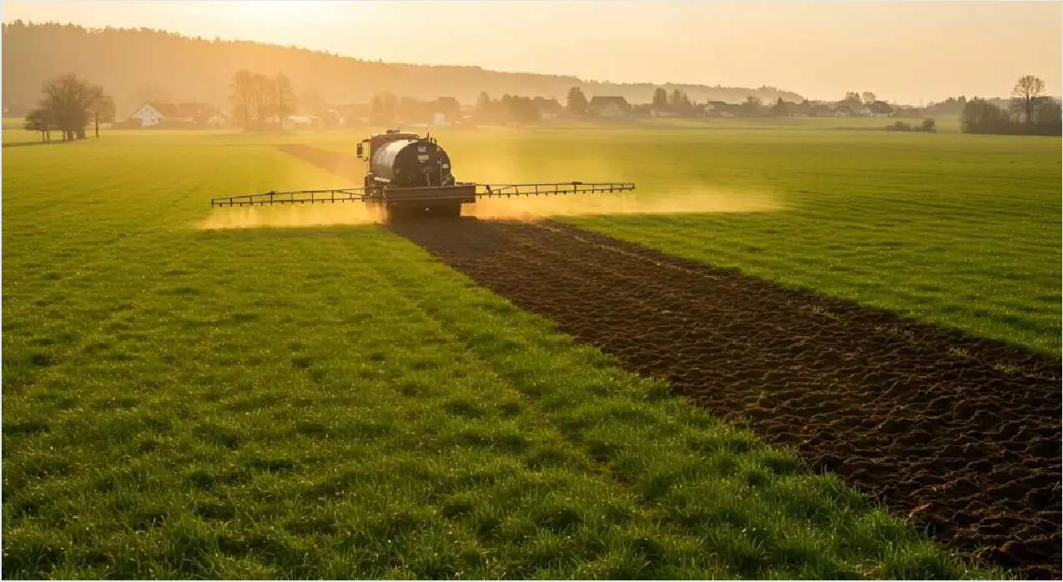
Engineered as a water-soluble hydrochloride salt, Chitosan AG delivers high-charge performance designed for modern crop inputs. Its low molecular weight structure supports efficient integration into agronomic practices without the solubility limitations of standard high-molecular-weight chitosan.
- Enhances early seedling vigor and seed coating performance.
- Integrates seamlessly into liquid foliar fertilizers and irrigation lines.
- Acts as a functional elicitor in sustainable crop protection protocols.

Chitosan IG: Industrial Performance
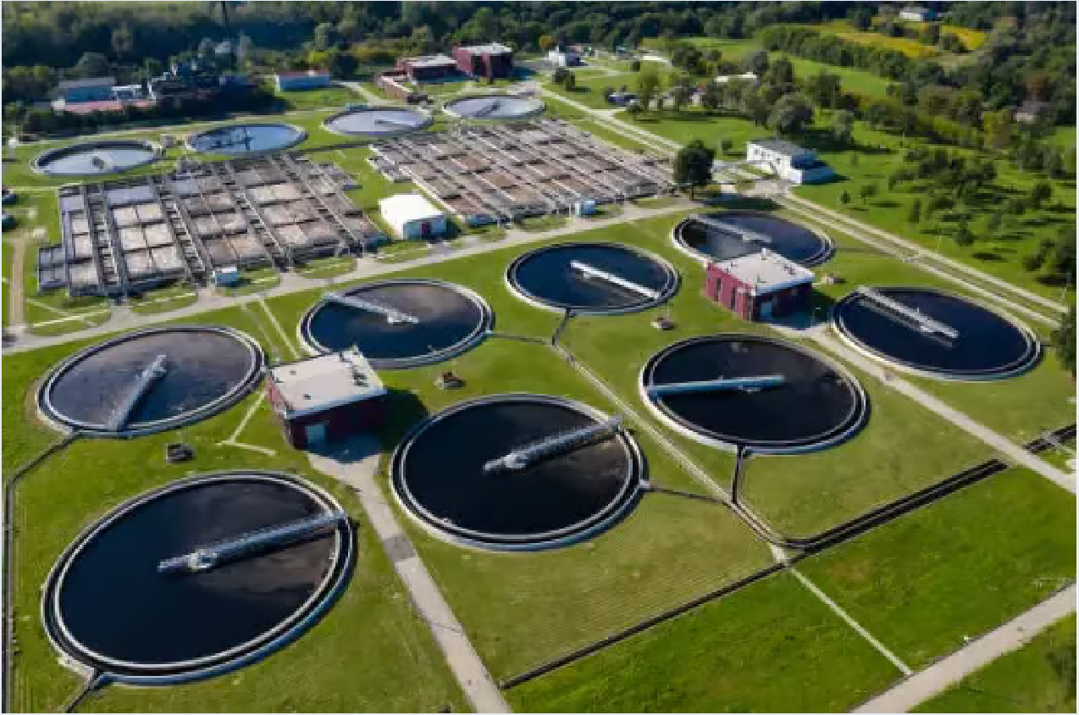
Chitosan IG leverages strong electrostatic binding capacity to serve as a potent cationic polymer in industrial settings. It offers an eco-friendly, biodegradable alternative to specific synthetic flocculants and resins in heavy-duty applications.
- Flocculation of suspended solids and comprehensive wastewater clarification.
- Binding capabilities for heavy metal and contaminant remediation.
- Bio-based structural component for sustainable material engineering and industrial coatings.

Chitosan FG: Food & Nutritional Grade


Formulated as a lactate salt for superior bioavailability and stability, Chitosan FG meets the stringent demands of the nutraceutical sector. Its refined oligosaccharide structure supports rapid absorption and functional efficacy.
- Bioactive ingredient for functional food matrices and nutritional drinks.
- Digestive support and gut microbiome formulations.
- Integration into metabolic wellness dietary supplements and encapsulated powders.

Built for Formulators

- Liquid Fertilizers & Sprays: High water solubility prevents nozzle clogging and ensures uniform distribution of the cationic polymer across leaf surfaces.
- Water Clarification: Rapid dispersion and strong positive charge enable swift binding with negatively charged particulates and organics in effluent streams.
- Dietary Supplements: The lactate salt formulation of FG provides a neutral taste profile and stable integration into capsules, tablets, and functional powders.
- Seed Coatings: Low molecular weight oligomers penetrate seed coats effectively, supporting germination treatments without physical binding or viscosity issues.

Commercial Source Directory

Chitosan AG Product Profile
Chitosan AG Purchase & Specifications Chitosan IG Product Profile
Chitosan FG Product Profile
Wholesale Pricing Directory Contact Technical Team

Ready to Formulate the Future?

Secure high-quality, verified bulk chitosan derivatives for your next commercial project. Review our pricing or connect with our technical team to discuss custom formulation requirements.

