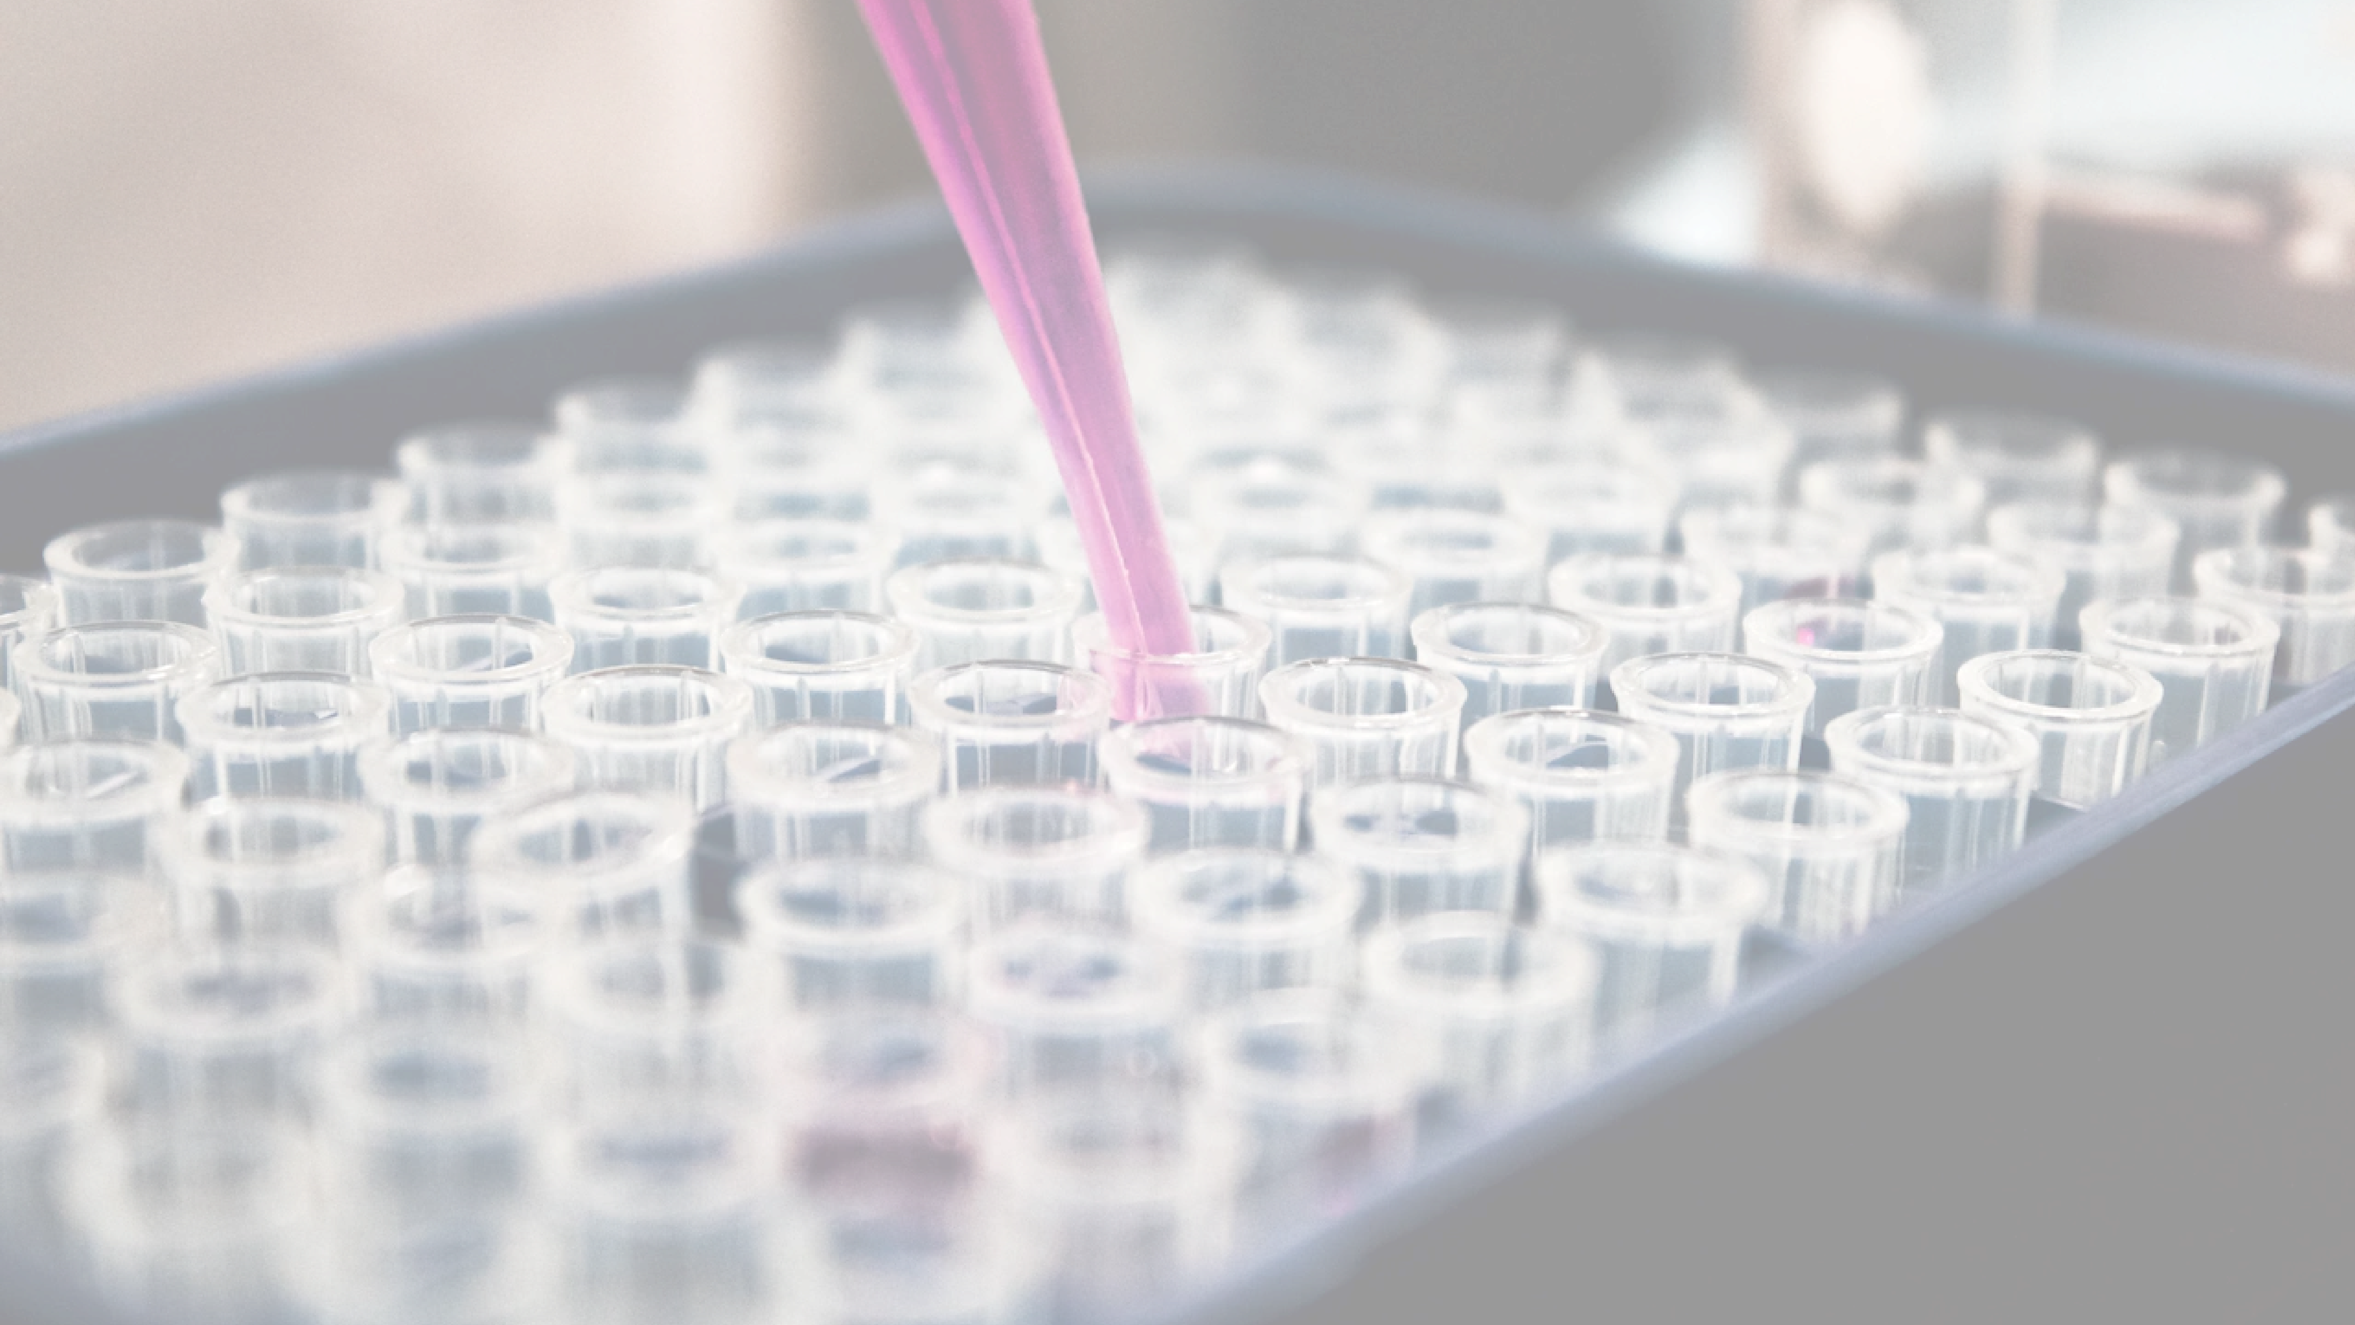

Chitosan in Cosmetics and
Personal Care Products
Scientific Advances and Applications
A COMPREHENSIVE REVIEW OF RECENT RESEARCH (2020–2025)
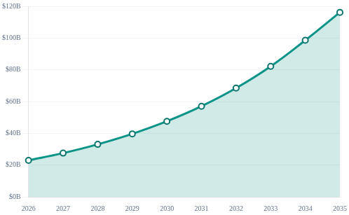
Introduction & Market Overview
Global Chitosan Market and Cosmetic Industry Growth

What is Chitosan?
A cationic polysaccharide derived from
chitin
(found in crustacean
shells, insect exoskeletons, and fungal cell walls) via deacetylation. It is
the second most abundant natural polysaccharide after cellulose.
✶
Rapid Market Expansion
The global chitosan market is valued at
$23.04B
in 2026 and is
projected to skyrocket to
$116.19B
by 2035, exhibiting a robust
CAGR of ~20%
.

Cosmetics Sector Growth
Specific to cosmetics, the segment is expanding with a steady
10.4
%
CAGR
, driven by the surge in demand for natural, bioactive ingredients
and sustainable polymer alternatives.
Global Market Forecast (USD Billion)
2026-2035
KEY DRIVERS
Sustainability
Clean Beauty
Bio-activity
COSMETICS CAGR
%
10.4
Segment
Growth Rate
S
o
u
r
c
e
s
:

P
r
e
c
e
d
e
n
c
e

R
e
s
e
a
r
c
h

2
0
2
6
;

F
o
r
t
u
n
e

B
u
s
i
n
e
s
s

I
n
s
i
g
h
t
s
;

B
u
s
i
n
e
s
s

R
e
s
e
a
r
c
h

C
o
.
© 2026 Promecens Entosystems / Shield Nutraceuticals

R
K
E
T

O
V
E
R
V
I
E
W
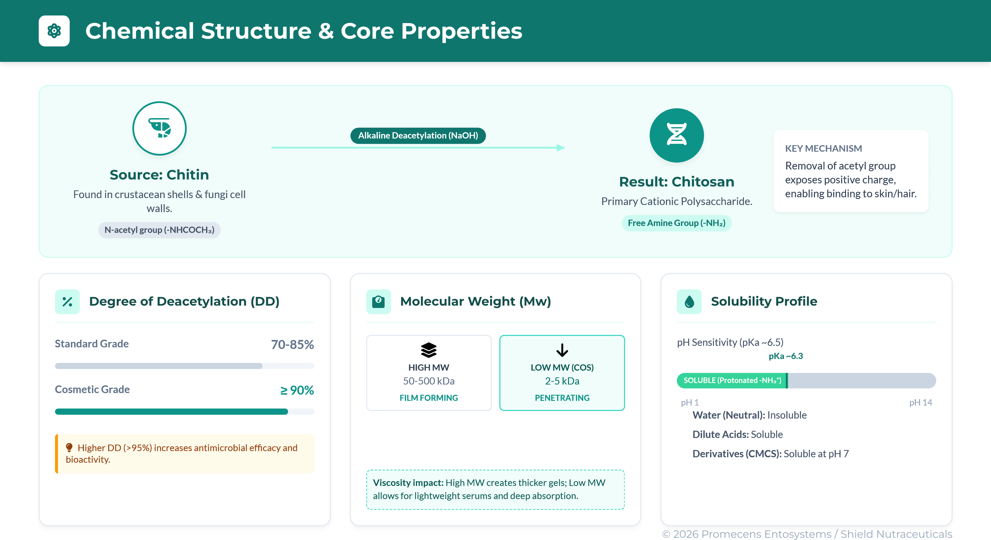
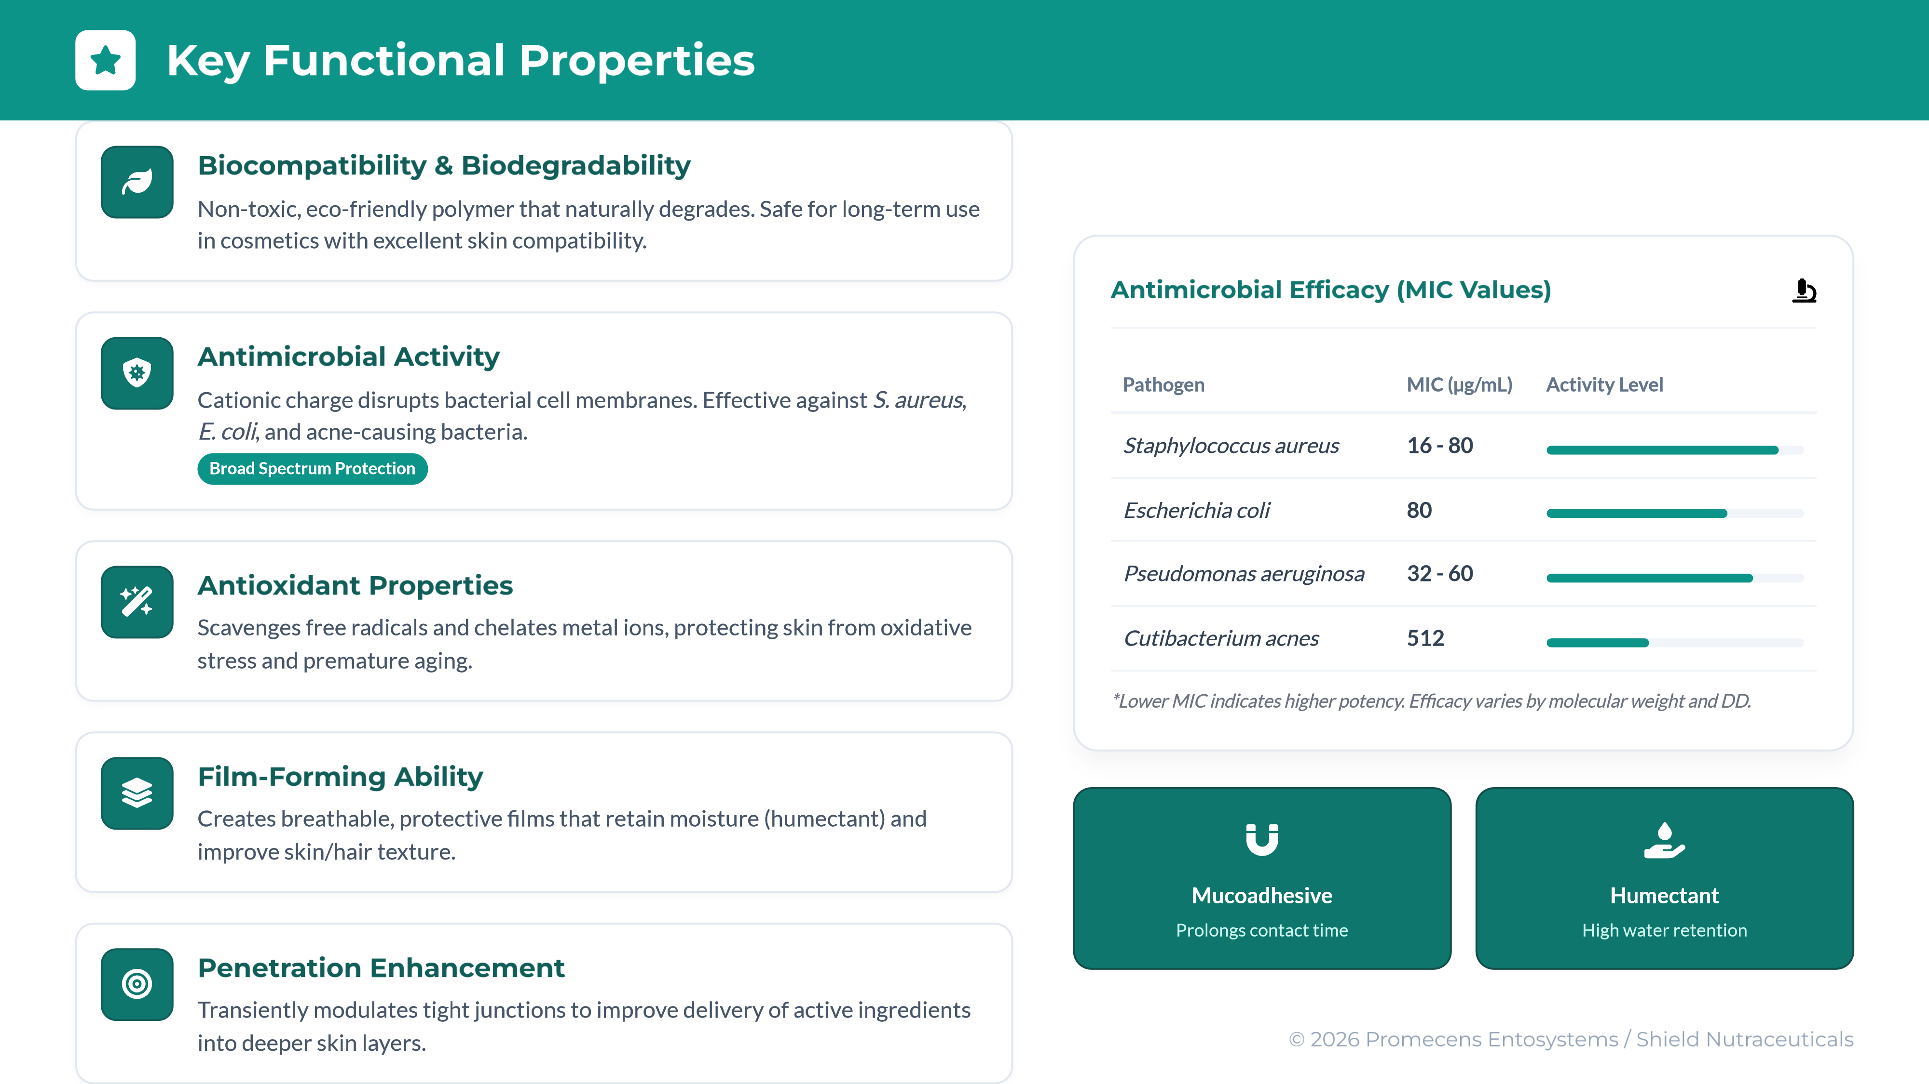
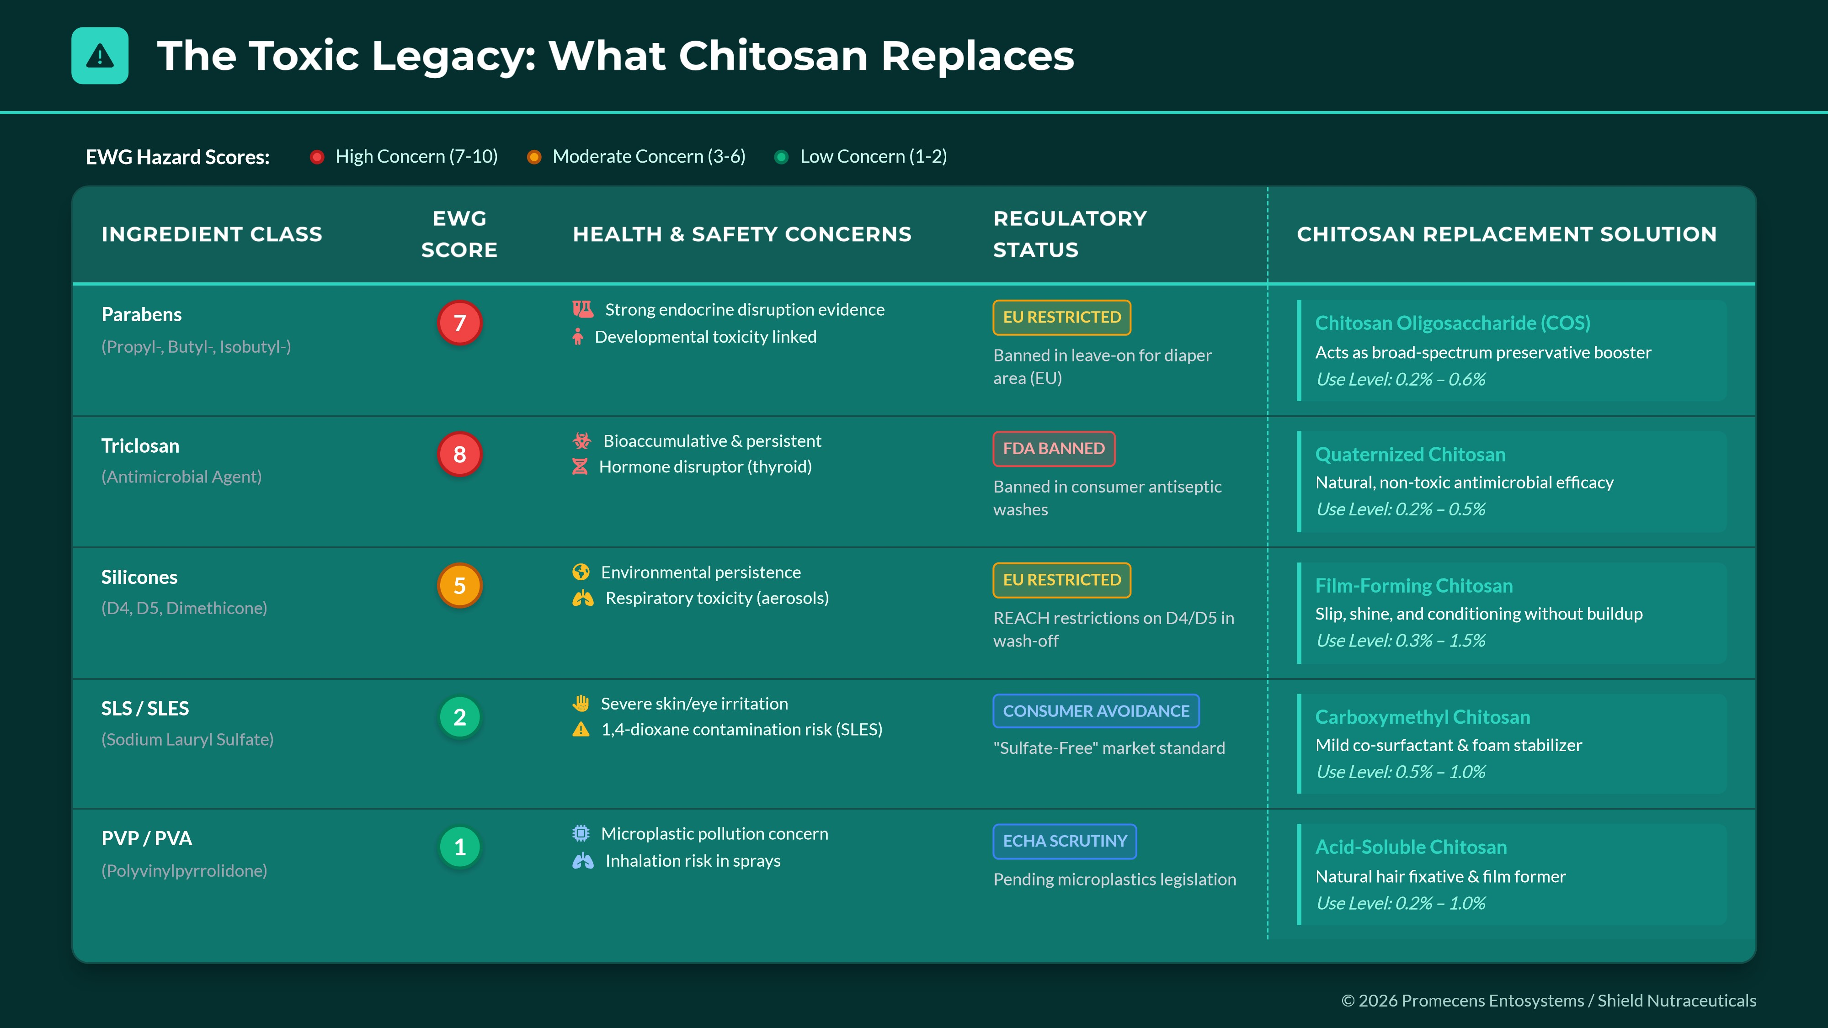
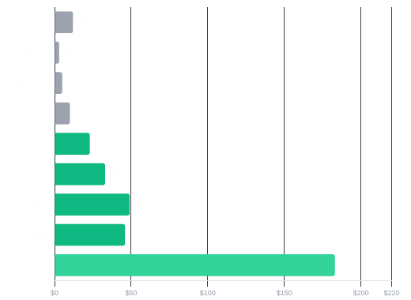
Cost Analysis: The Economic Case for Chitosan
Strategic Investment for Premium Formulation & Regulatory Resilience
Ingredient Cost Comparison ($/kg)
Cost vs. Value Proposition
While unit cost is higher, chitosan replaces multiple ingredients (preservative boosters, film formers,
humectants) simultaneously, reducing total formulation complexity.

Batch Economics (1,000 kg)
TRADITIONAL
Parabens @ 0.3%
$36.00
$12/kg avg
)
(
CHITOSAN ALT
COS @ 0.5%
$230.00
$46/kg avg
)
(
N
e
t

i
n
c
r
e
a
s
e

o
f
f
s
e
t

b
y

c
l
e
a
n

l
a
b
e
l

p
r
e
m
i
u
m

(
+
1
5
-
2
0
%

r
e
t
a
i
l

p
r
i
c
e
)

Film Former Replacement
TRADITIONAL
Dimethicone @ 1.0%
$60.00
)
$6/kg avg
(
CHITOSAN ALT
Chitosan @ 0.8%
$184.00
)
$23/kg avg
(
ROI & MARGIN DRIVERS
✓
Reduced SKU Complexity
✓
EWG-Friendly Labeling
✓
Price Premium Capture
✓
Regulatory Resilience
© 2026 Promecens Entosystems / Shield Nutraceuticals

N
O
M
I
C

A
N
A
L
Y
S
I
S
CATEGORY
REPLACES
INGREDIENT
PRIMARY CONCERN
CHITOSAN
DERIVATIVE
CONC. %
PERFORMANCE ADVANTAGE

Skincare
Glycerin / Synthetic
Humectants
Sticky feel, poor film-forming
CMCS / COS
0.3 -
1.0%
HYDRATION
Higher water binding
capacity + protective
breathable film reducing
TEWL

Anti-Acne
Triclosan / Benzoyl Peroxide
Skin irritation, dryness,
toxicity
Chitosan Oligosaccharide
(
COS
)
0.2 -
0.8%
HEALING
Potent antimicrobial vs C.
acnes + accelerates wound
healing without irritation
☀
Sunscreen
PVP / Silicone Gums
Microplastics, environmental
persistence
Chitosan HCl
1.0%
0.5 -
FILM
FORMING
Superior water resistance
and SPF boosting effect
without synthetic
polymers

Hair Styling
PVP / PVA / Acrylates
Synthetic buildup, flaking,
stiff feel
High MW Chitosan
1.0%
0.2 -
HOLD
Flexible hold with excellent
high-humidity resistance and
conditioning

Deodorants
Triclosan / Aluminum Salts
Endocrine disruption, pore
clogging
Quaternized Chitosan / COS
0.2 -
0.6%
MICROBIOME
Selective inhibition of
odor-causing bacteria
while respecting skin
flora
Prolonged plaque
t
l
i
© 2026 Promecens Entosystems / Shield Nutraceuticals

Ingredient Replacement Matrix
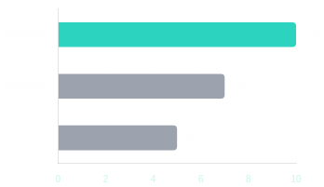
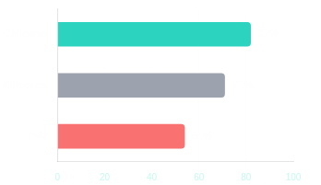
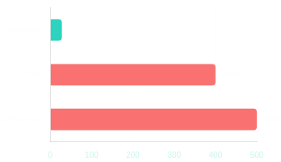
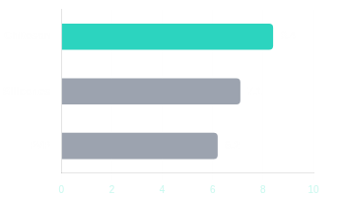
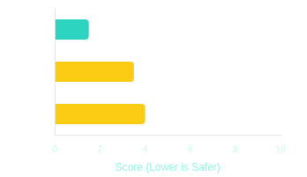
Chitosan (Natural)
Synthetic (Acceptable)
Synthetic (Poor/Risk)
Film Durability (Hours)

Humidity Resistance (%)

WINNER
Chitosan Wins
5
/5 Metrics
Superior performance without the synthetic drawbacks
Biodegradability (Days)
●
Consumer Satisfaction (0-10)
⭐
EWG Safety (Lower is Better)

© 2026 Promecens Entosystems / Shield Nutraceuticals

Performance Comparison: Film-Forming & Conditioning

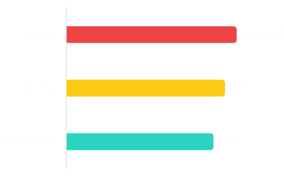
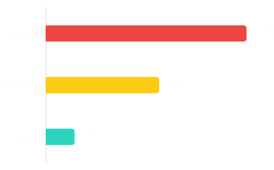
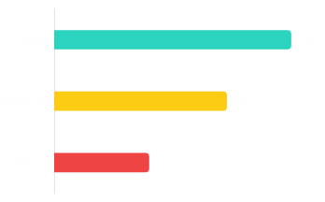
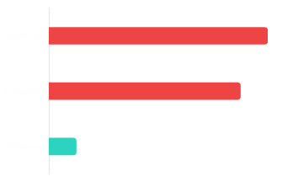
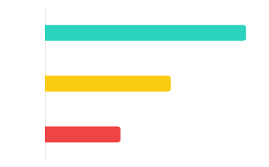

Chitosan:
Safer & Future-Proof
Superior safety profile with potent antimicrobial
efficacy without the regulatory risks.
Bacterial Reduction (24h)

Skin Irritation Reports

Regulatory Approval (Countries)
✶
Endocrine Disruption Risk (EWG)

Long-term Safety Data (Years)


Performance Comparison: Antimicrobial & Preservation
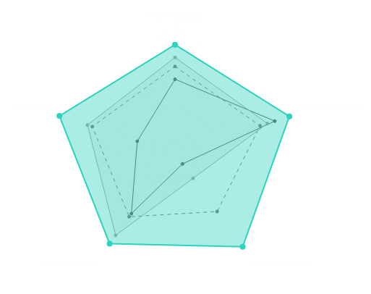
Performance Comparison: Moisturization &
Skin Feel
Chitosan CMCS vs. Traditional Humectants & Emollients

Chitosan CMCS: Best Overall
Performance
Holistic Performance Profile
Chitosan CMCS
Hyaluronic Acid
Glycerin
Dimethicone
Metric-by-Metric Breakdown
Water Retention (24h)
CMCS Wins (+10%)
Dimethicone: 58%
HA: 75%
TEWL Reduction
Superior Barrier
Glycerin: 35%
Dimethicone: 41%
Skin Penetration Depth
Deep Hydration
Dimethicone: 5
μ
m
Glycerin: 28
μ
m
Non-Greasy Feel (Consumer Rating)
User Preferred
Dimethicone: 5.8
HA: 7.9
Environmental Impact Score
Eco-Champion
Dimethicone: 3.1
HA: 7.2
© 2026 Promecens Entosystems / Shield Nutraceuticals
85
%
47
%
45
μ
m
8.7/10
9.5/10

E
R
F
O
R
M
A
N
C
E
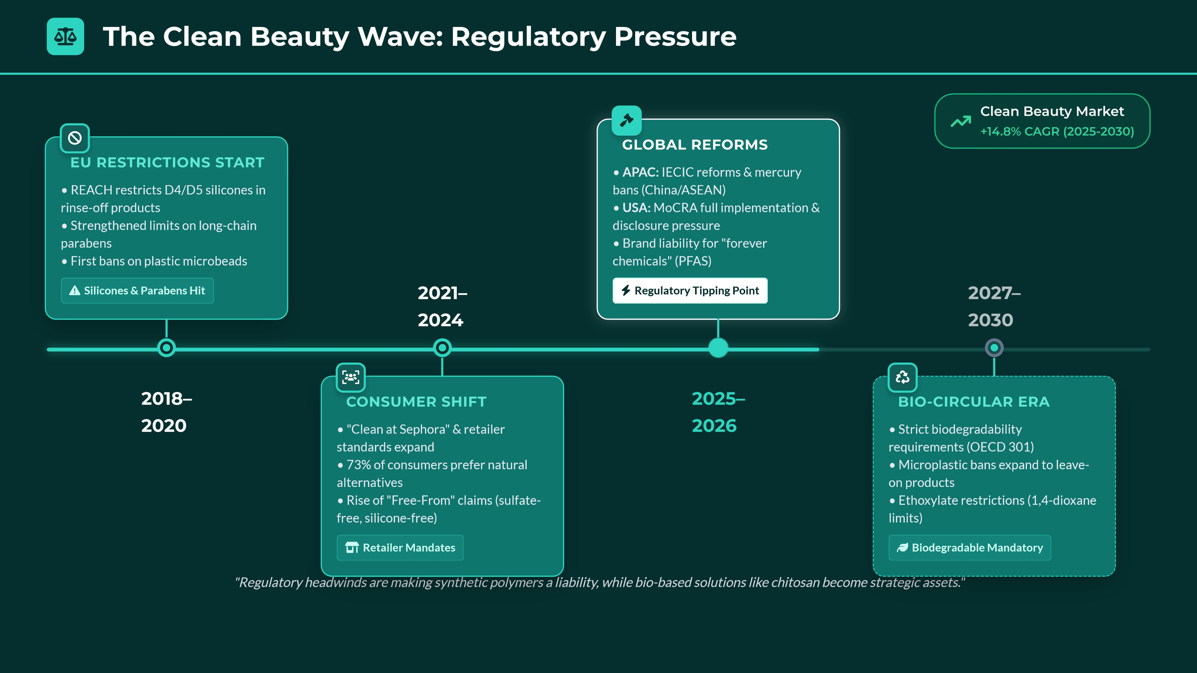

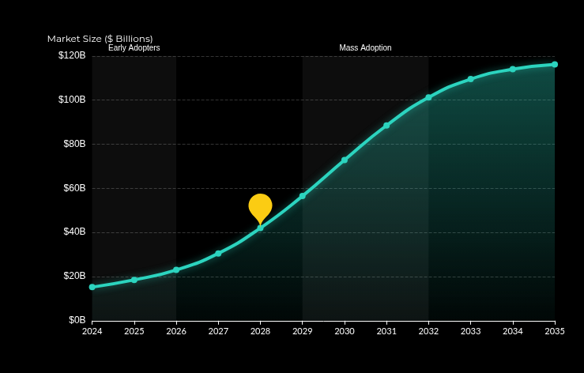

Explosive Growth Trajectory
20
% CAGR
Market projected to grow from
$23B (2026)
to
over
$116B (2035)
, driven by clean beauty
mandates.

The 2027-2028 Tipping Point
Critical inflection point where large FMCG
portfolios shift to green polymers at scale.
Cosmetic applications drive
40
% of this surge
.

Dominance Forecast
By 2033, chitosan establishes market dominance
as the standard replacement for PVP and
silicones in premium formulations.
Global Chitosan Market Adoption (2024-2035)
Market Size ($B)
⚡
TIPPING POINT

Market Demand Surge: The Tipping Point
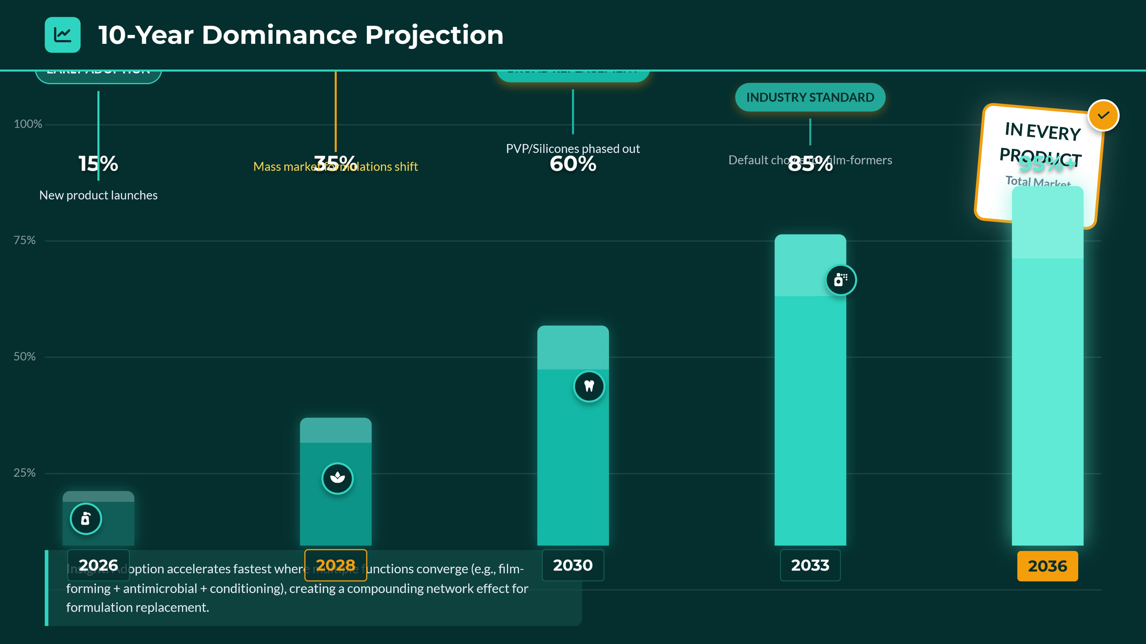
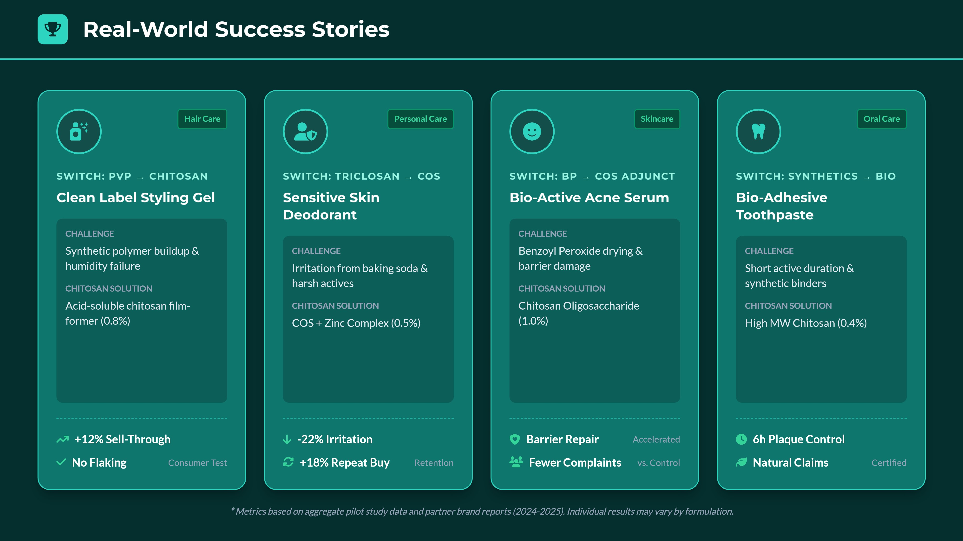

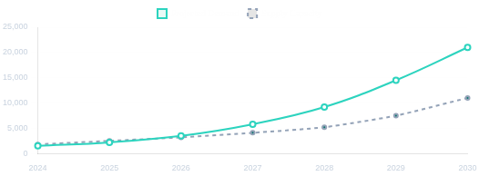
The Investment Opportunity
Supply/Demand Dynamics & Real-World ROI
⚠
Supply/Demand Gap Alert
Capacity expansions lag projected cosmetics uptake by
18
–24 months
. Strategic
sourcing via fungal/insect routes offers early-mover advantage before 2027.
ROI VALUE STACK
Key Drivers
4

Compliance Risk
↓
$
Premium +8-15%

SKU Simplification

Future-Proofing

CASE 1: K-Beauty Brand Transition (2024)
$2.40 Margin/Unit
+
Switched silicones to chitosan film-formers.
BEFORE:
)
3.2
% returns (buildup
COST:
$4.80/kg ingredient
AFTER:
1.1
)
% returns (-66%
RESULT:
18
% Price Premium
●
CASE 2: EU Natural Hair Line (Q3 2025)
% Sell-Through
+31
New styling line launched with chitosan vs PVP.
✓
Achieved "EWG Verified"

Whole Foods stores
340
Rating:
4.7/5.0
)
vs 3.9 avg
(
Impossible with PVP

Cost Portfolio
Acid-Soluble:
$23-33
COS:
$46
Quats:
$49
CMCS:
$120+
SECURE VOLUMES NOW
Co-develop hero SKUs ahead of the
inflection point
2027–2028
.
Supply vs. Demand (MT)
Gap Widening 2026-28
© 2026 Promecens Entosystems / Shield Nutraceuticals

V
E
S
T
M
E
N
T

C
A
S
E

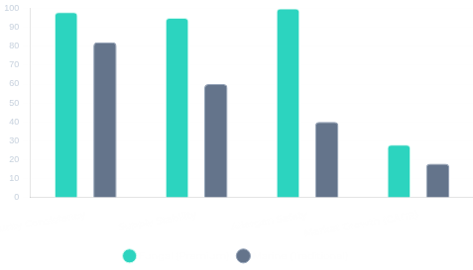
REAL-WORLD SUCCESS STORIES

Japanese Cosmetics Pioneer
2023
Switch
Major J-Beauty brand transitioned from marine to fungal chitosan to resolve batch inconsistency.
Purity Consistency
%
98.5
±
1.5%
Supplier Rejections
ZERO
(18
mos
)
Vegan Sales
+44
% Growth

US Premium Skincare Startup
2024
Launch
Launched exclusively with insect-derived (BSF) chitosan for "Zero Ocean Impact" sustainability.
Seed Funding
$2.8M
Raised
Retention Rate
89
%
Loyalty
Proj. Revenue
$12M Year 1
Purity Consistency & Market Growth


365
days
FUNGAL PRODUCTION
VS SEASONAL MARINE

98
%+
CONSISTENT DD PURITY
(
PREMIUM STANDARD
)

28
%
COSMETICS CAGR
)
FASTEST GROWTH
(

Traditional: Marine
$19-27/kg
Seasonal harvesting gaps.
% DD Var.
85-95
Allergen Risk
Fungal vs. Marine
© 2026 Promecens Entosystems / Shield Nutraceuticals
Future: Fungal
$35-55/kg
365-
day resilience.
%+ DD Purity
98
Hypoallergenic
PREMIUM
⭐
Sources of Chitosan: Why Fungal is THE Future
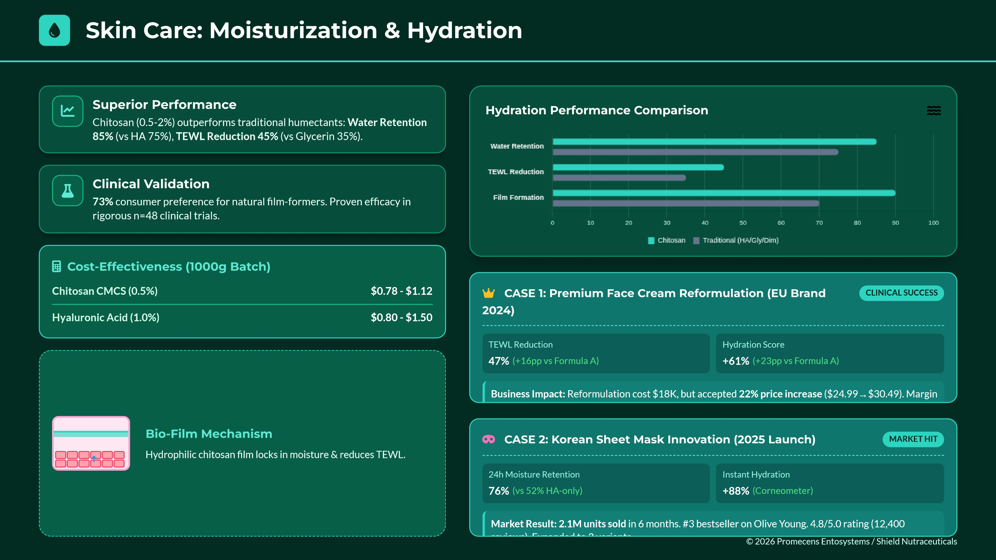
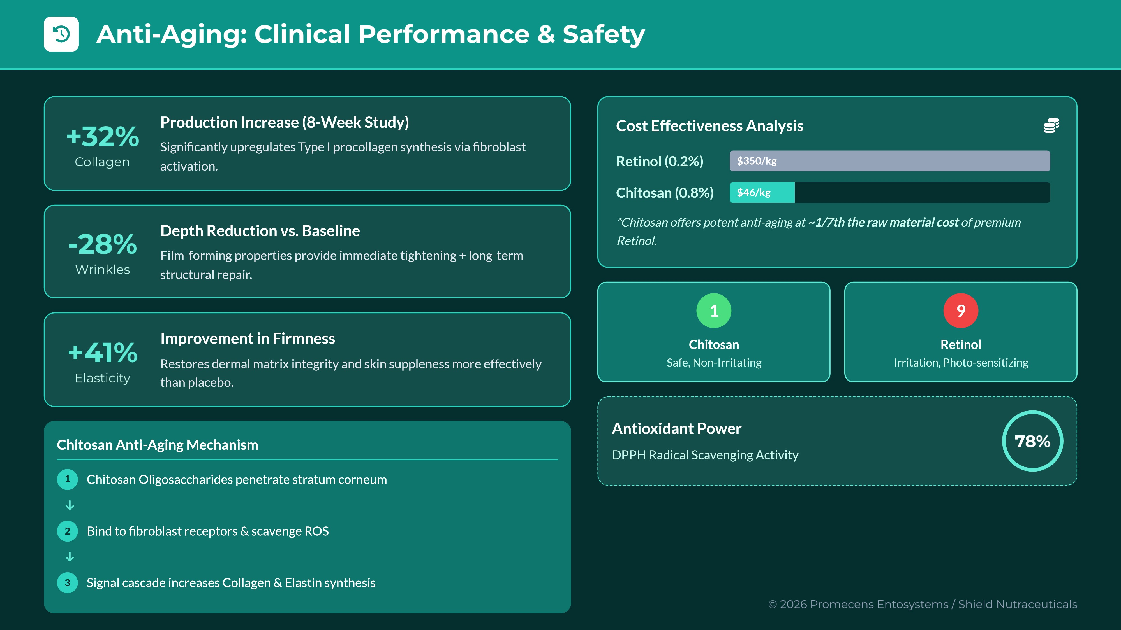
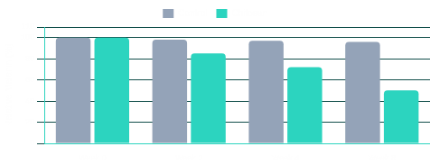

Melanogenesis Inhibition
Chitosan downregulates tyrosinase activity (-38.2%) and blocks melanosome
transfer to keratinocytes (Chen et al. 2020).

High Efficacy Evidence
Studies confirm
50
% reduction
in cellular melanin at 100 µg/mL. Collagen-
Chitosan complexes show synergistic potency.

8
x More Cost-Effective
Chitosan COS (0.5%)
$0.23
Kojic Acid (2%)
$1.70 - $2.40
*
B
a
s
e
d

o
n

$
4
6
/
k
g

C
O
S

m
e
a
n

v
s

$
8
5
-
1
2
0
/
k
g

K
o
j
i
c

A
c
i
d

Formulation Synergy
Compatible with niacinamide and Vitamin C. Stabilizes actives while providing
its own brightening mechanism.
Melanin Reduction Over Time

per 1000g batch
per 1000g batch
Tyrosinase Inhibition Pathway

Tyrosinase
Chitosan
Oxidation
Tyrosine
Dopaquinone
Melanin
⭐
Skin Care: Brightening & Tone Evenness
© 2026 Promecens Entosystems / Shield Nutraceuticals
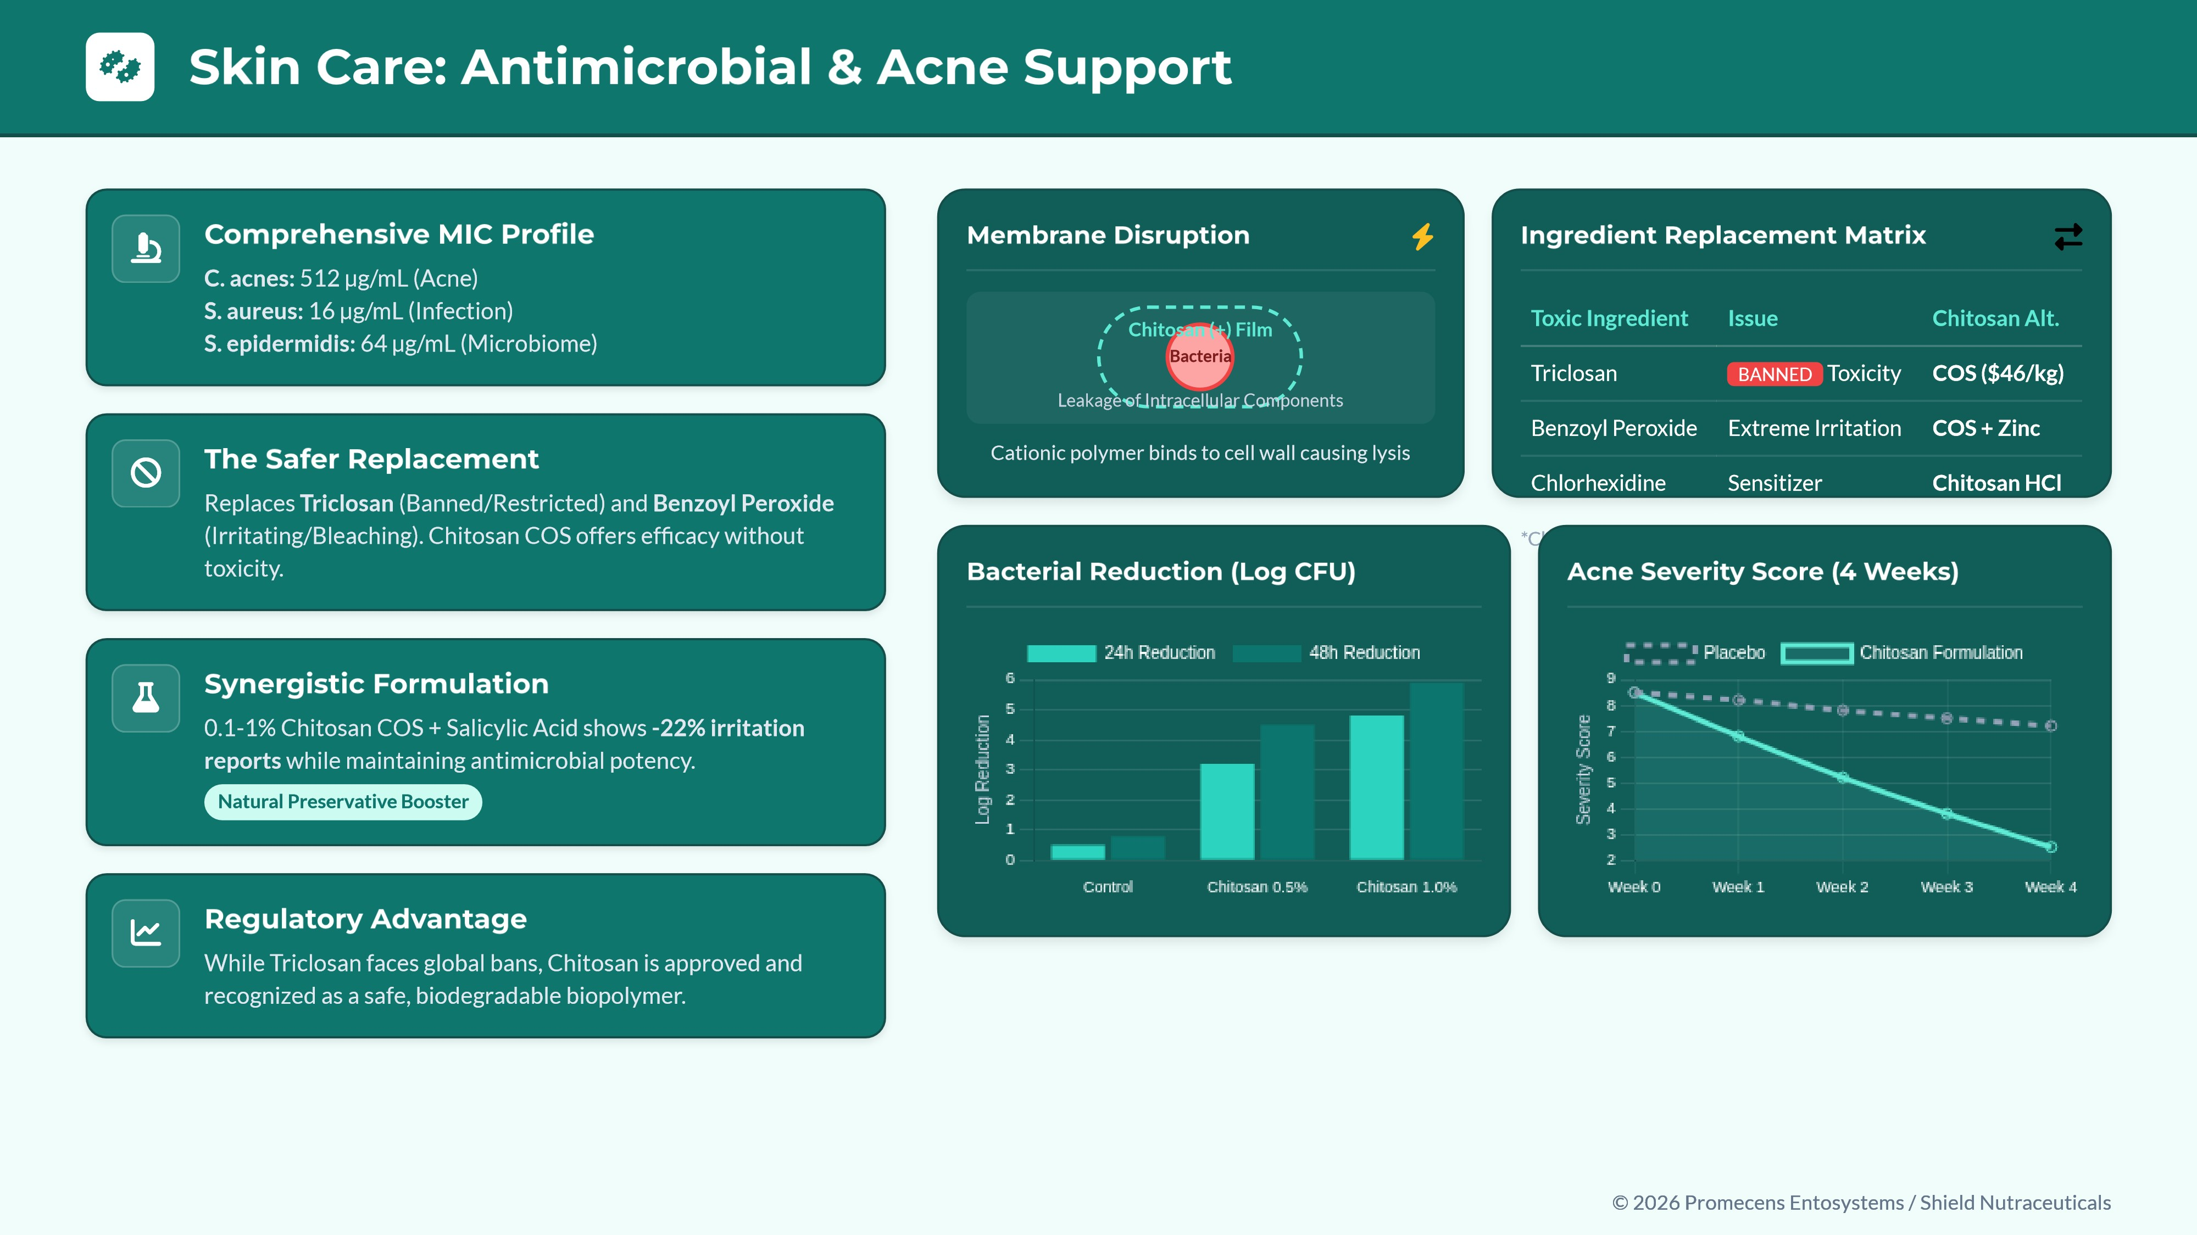
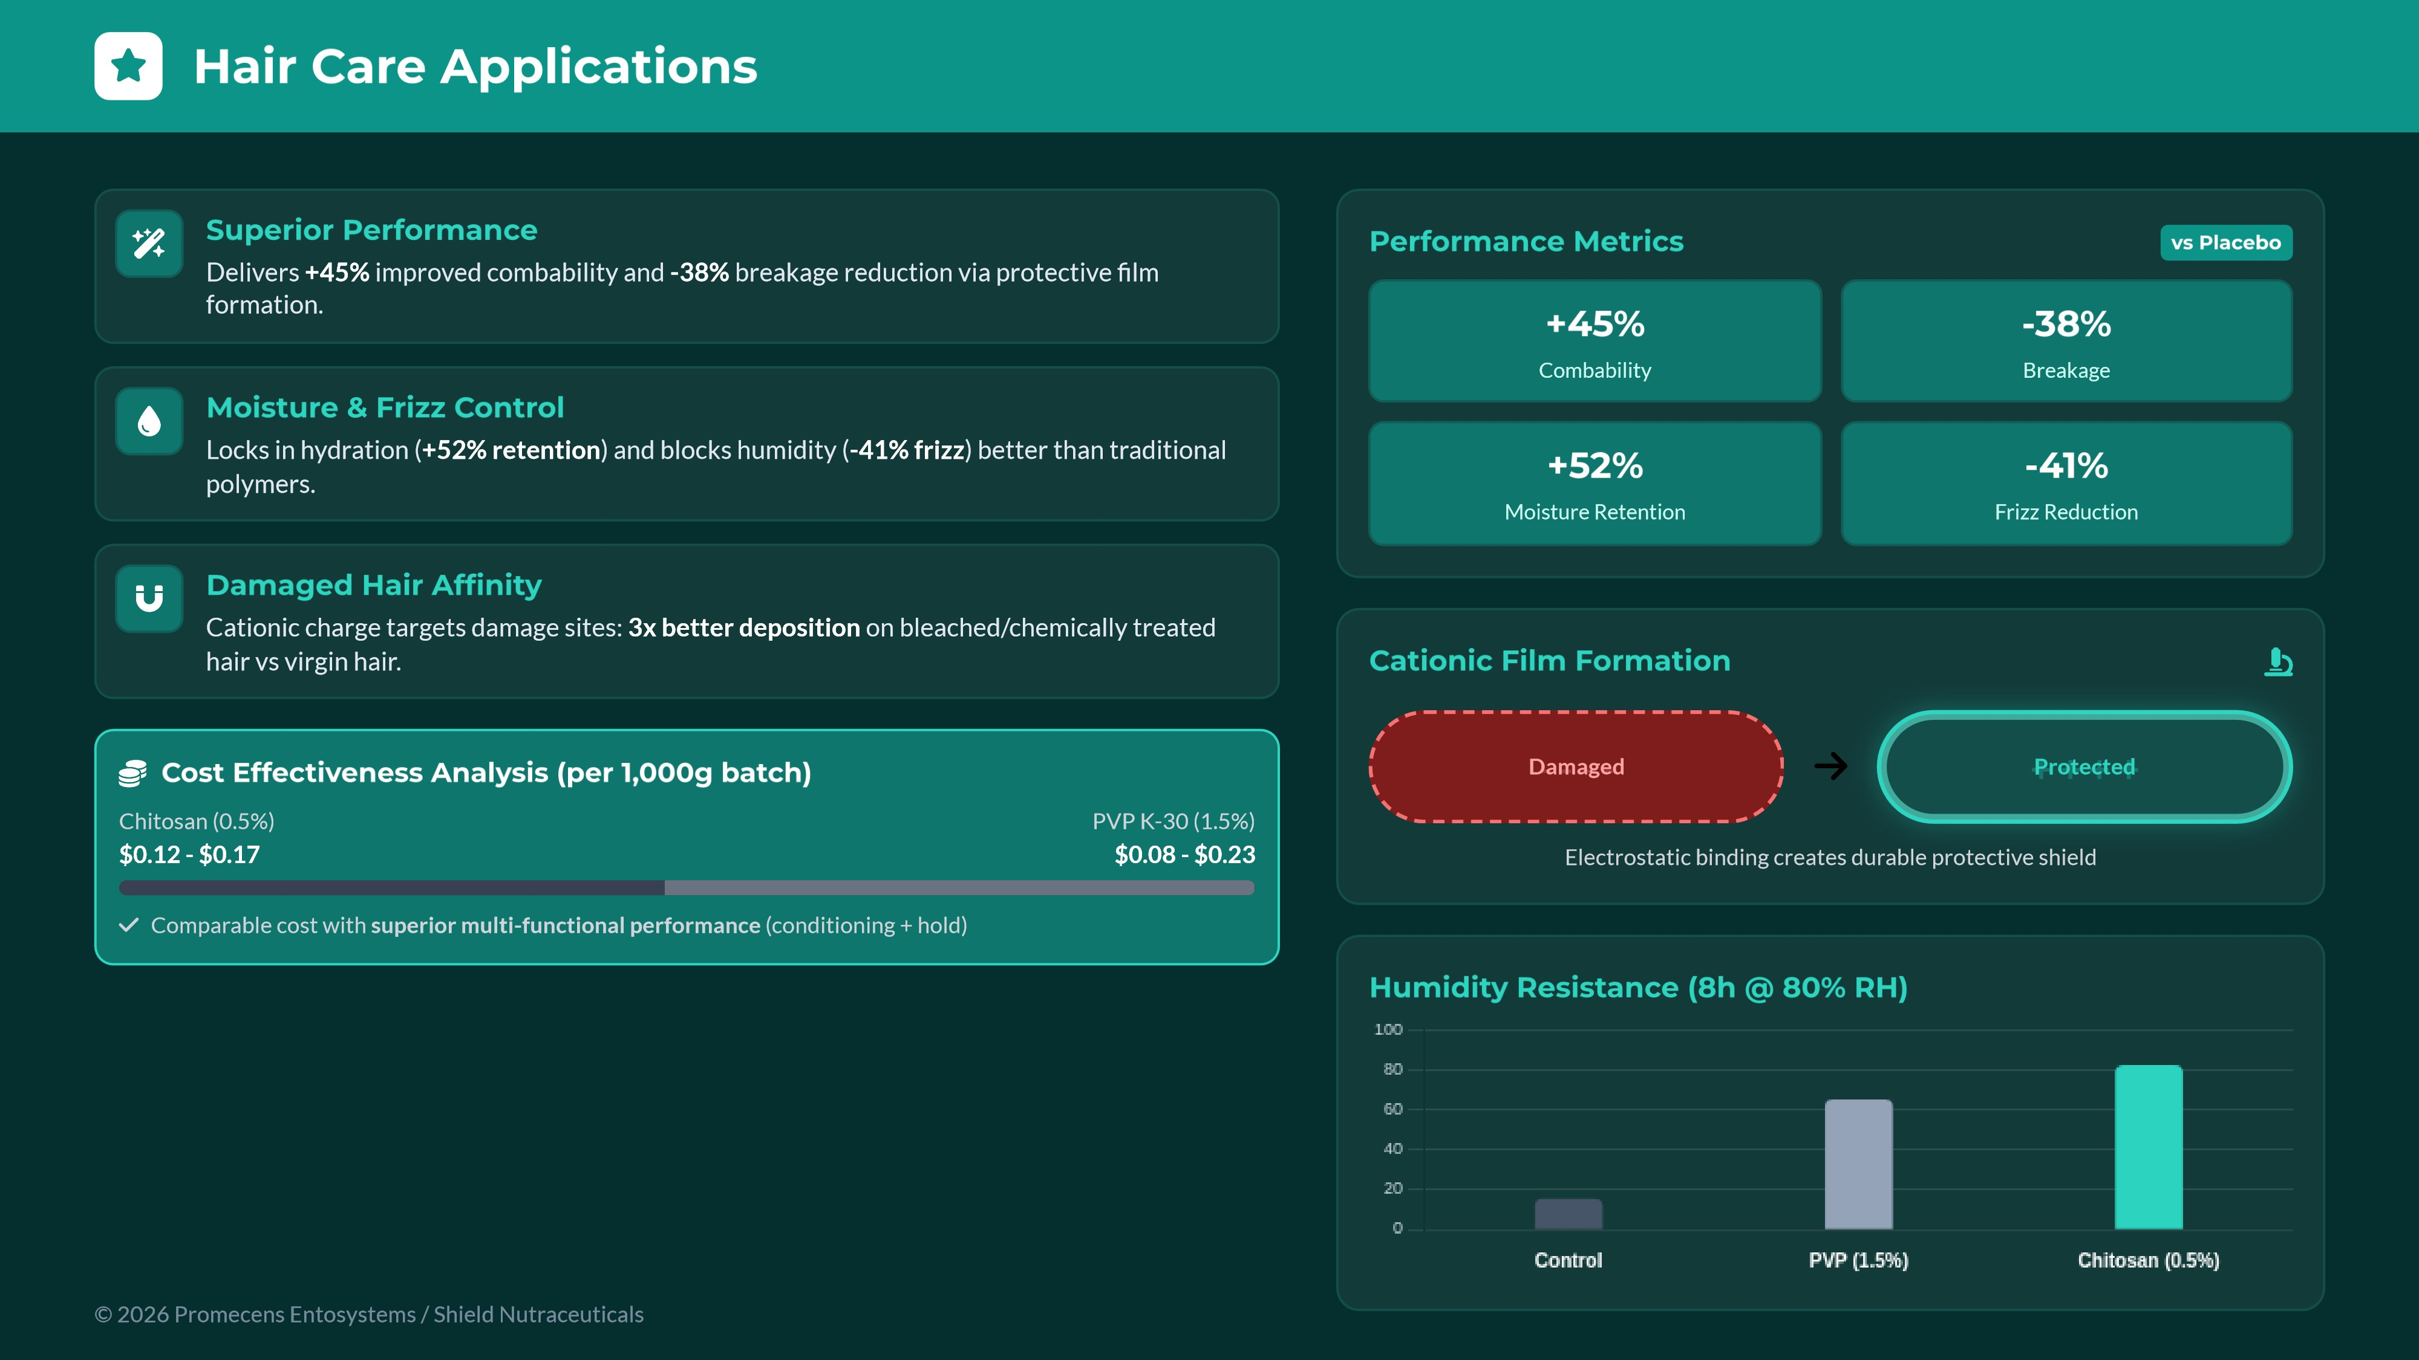
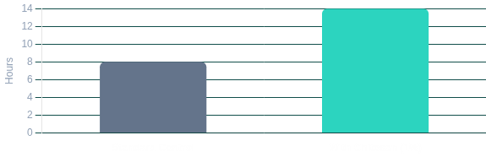

Foundations (Long-Wear)
Film-forming properties extend wear-time by +6 hours. Improves pigment
dispersion.
Conc: 0.5 - 1.5%
■
Mascaras (Conditioning)
Coats lashes for volume without clumping. Conditions and strengthens
lashes.
Conc: 0.8 - 1.2%

Deodorants (Antimicrobial)
Natural efficacy against odor-causing bacteria. 24h protection without
aluminum.
Conc: 0.2 - 0.6%

Oral Care (Bioadhesive)
Adheres to enamel/mucosa for prolonged plaque control (-34%
reduction).
Conc: 0.1 - 0.5%
+6
h
Makeup Longevity
24
h
Deodorant Protection
-34
%
Plaque Reduction
Cost Analysis: Foundation Formulation

Cyclomethicone (Traditional)
$3-7/kg @ 3%
Chitosan (Clean Label)
$33/kg @ 1%
*
C
l
e
a
n

l
a
b
e
l

p
r
e
m
i
u
m

+

l
o
w
e
r

u
s
a
g
e

r
a
t
e

j
u
s
t
i
fi
e
s

h
i
g
h
e
r

u
n
i
t

c
o
s
t
.

R
e
p
l
a
c
e
s

s
y
n
t
h
e
t
i
c

s
i
l
i
c
o
n
e
s
.
Makeup Wear-Time Comparison (Hours)

© 2026 Promecens Entosystems / Shield Nutraceuticals

Makeup & Personal Care Applications
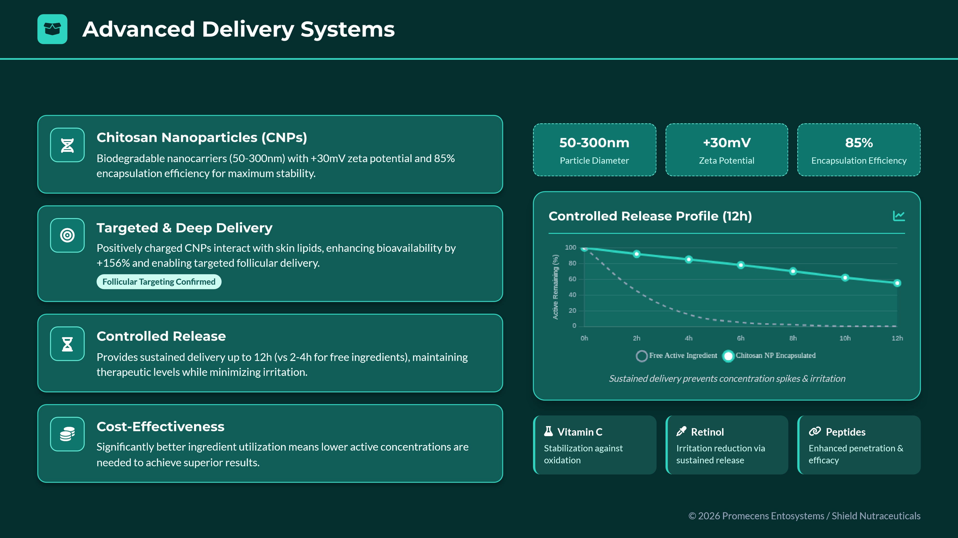
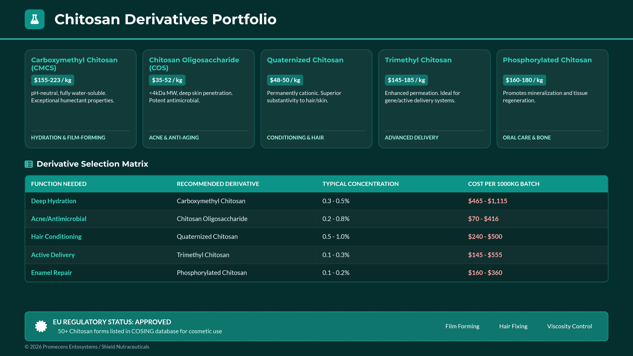
Sustainability & Market Trends
Eco-Friendly Innovation Driving the Clean Beauty Revolution
Natural Ingredients Market
$1.8 Trillion
Projected by 2035
Biodegradation Time
28
Days
400
Yrs
●
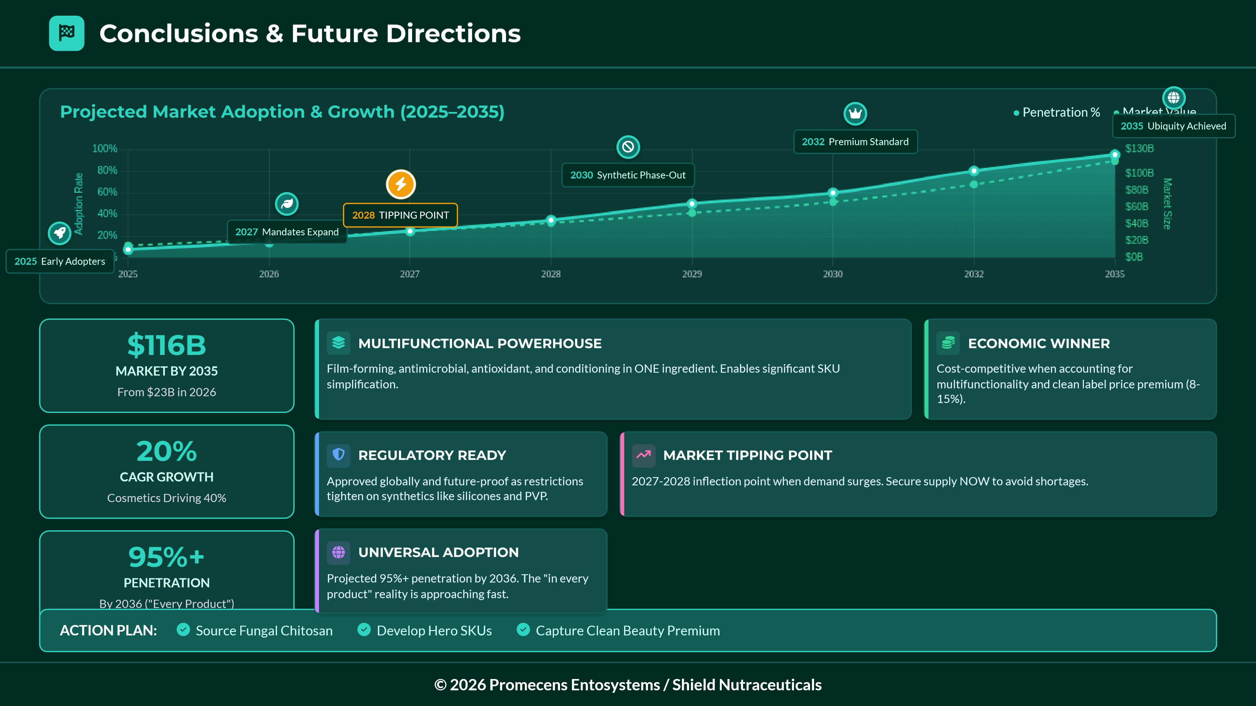
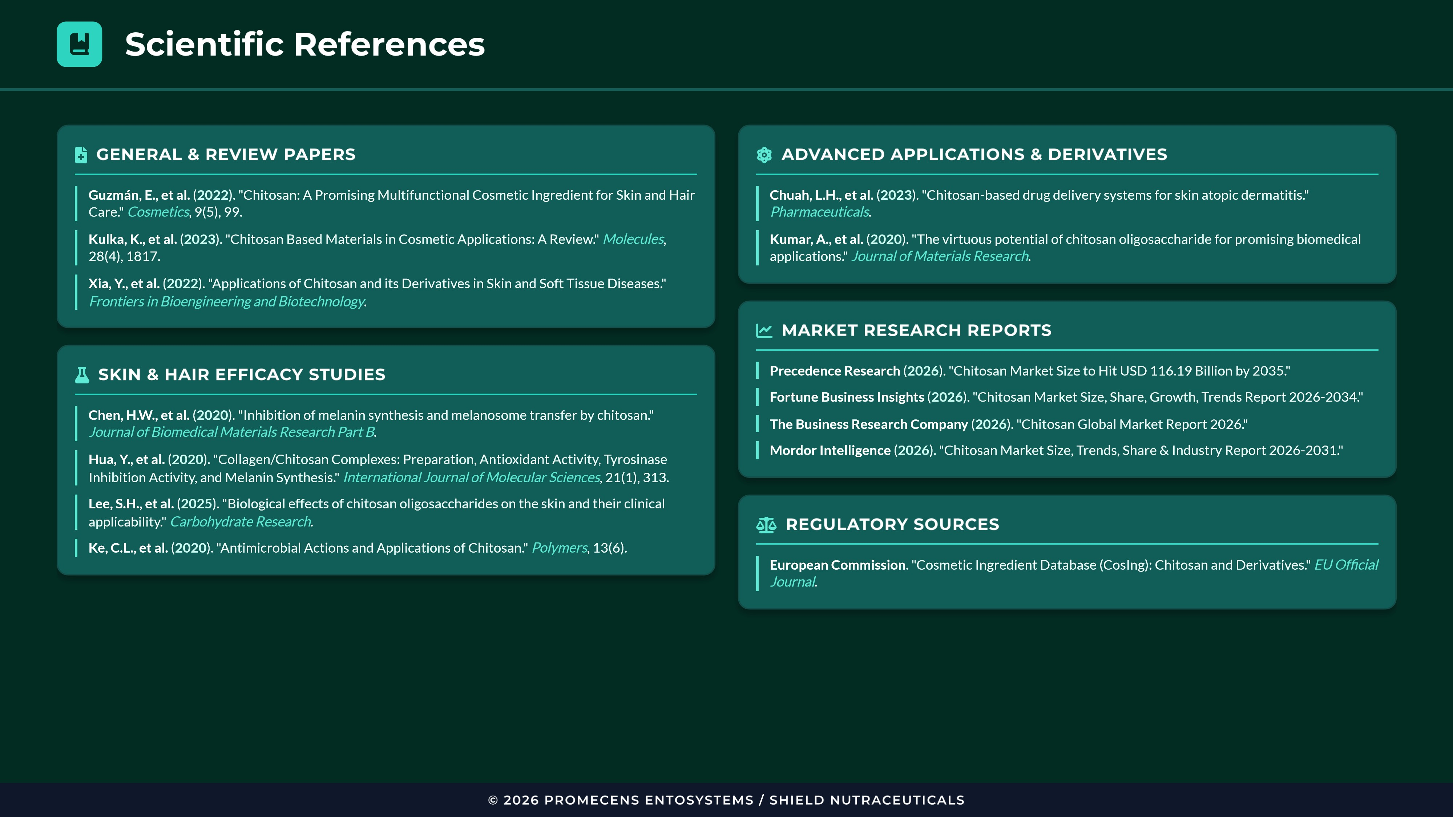
Promecens
Entosystems
Shield Nutraceuticals
✶
Website
chitosanglobal.com
✉
Contact
Form available online

Location
Global Operations
Areas of Expertise
We provide high-quality chitosan solutions across diverse industrial sectors:
⇨
Medical Applications

Food & Dietary Supplements

Personal Care & Cosmetics

Agricultural Solutions

Industrial Applications

Research & Development

Partner With Us
Whether you're looking to purchase wholesale chitosan or discuss a custom project,
our team is ready to assist with technical specifications and product quotations.
Book a Consultation
Not sure which chitosan type fits your needs?
Schedule a free 30-minute consultation with
our experts.

Book a Call
© 2026 PROMECENS ENTOSYSTEMS / SHIELD NUTRACEUTICALS

